Welcome to your
modern Office
The new Office is personalized, cloud-connected and simpler than ever. The new Office works the way you do and helps you get more done at home, on the job and on the go.
Take Office with you and share and collaborate on documents with friends, family and colleagues. Your Office applications, documents and personal settings go wherever you go. Consumers can store Office documents on SkyDrive, and businesses can post documents to SharePoint and access them anywhere, share them at will and even work together on them in real time. Office works across devices and platforms, from smartphones and tablets to desktops and from PCs to Macs, and even on popular browsers.¹
The new Office is designed to work closely with Windows on PCs, tablets and phones. The fast and fluid experience lets you do more in less time, with minimalist styling and an intuitive touch and inking experience built into all the Office applications. Create a Word document on your PC and edit it on your Windows Phone with great fidelity, move from a keyboard to using touch seamlessly, or stream a full-featured version of Office to any Windows 7- or Windows 8-based PC with an Internet connection — with your personal settings intact.
The sleek and modern interface gives you faster access to the tools you use every day with the ability to customize your experience in every Office application. New tools help you make beautiful modern documents, lead productive meetings and transform data into insight in a matter of clicks. The new Office user interface is also easy on the eyes, with a clean, functional appearance — less chrome and more touch friendly, more get-it-done.
Making your documents look their best is now easier than ever. Office helps you create quickly with a menu of enhanced, professional templates and a list of your recent documents. Use new alignment guides to place pictures and other visual elements in perfect alignment within the paragraph, or experiment with your layout and see text flow around your images and other content with live layout functionality.
With Peeks, Office gives you the information you need at a glance without leaving your current view. View your schedule, a specific appointment or details about the person you’re emailing, all without opening additional windows or adding clicks to your workflow.

Get Office in the way that works for you
The new Office is available in a number of editions to suit business, home and educational needs.
- Office 365: Delivers the new Office as a subscription service, constantly updated and connected to Microsoft cloud services. It is available in business, consumer, education and government editions.
- Office 2013: Office as traditional desktop software with a perpetual license. Combined with a free Microsoft Account, Office 2013 offers many conveniences of a cloud-connected Office such as online document storage and sharing.
- Office on Windows RT: Devices running Windows RT will come with Word, Excel, PowerPoint and OneNote.
- Office servers: Exchange, SharePoint, Project and Lync are available hosted in the cloud as part of Office 365 for businesses, deployed on-premises, or a combination of both in a hybrid deployment.

Modern user interface
The new Office is more than just another pretty face. It’s designed to get out of the way and help you get things done. It’s sleek, streamlined and easy on the eyes with crisp animations, vivid colors and easy navigation with a mouse or touch. With a familiar, highly intuitive user experience it’s easy to get up and running whether you’re an Office power user or you’ve never used it before.

Experience Office at its best on Windows 8 devices
Office was made for Windows 8 on PCs and tablets, as well as Windows Phones. Try them together for the ultimate productivity experience. The beautiful design is optimized for a range of hardware: from compact, touch-enabled tablets and lightweight laptops to powerful all-in-ones with big high-definition screens. It’s smooth and intuitive and gives you instant access to your people, apps and documents, so you spend less time searching and more time doing.

Fresh, fast and fluid user interface
Windows 8 and the new Office both have a bold, beautifully designed new style that’s sleek and modern. From the clean look of the words on your screen to the way apps animate, the experience is fresh and the way it works is intuitive. The streamlined, user-focused design creates a productivity experience that is both functional and gorgeous.

Touch, pen, keyboard — your choice
Office is optimized for different experiences. When you’re on the go with your tablet or mobile phone, the new Office touch experience makes it easy to communicate, consume content and perform lightweight editing with the flick of your finger or the stroke of a pen. When you are at your desk with a keyboard and mouse, you have the full range of fine-tuned Office controls at your command for the most demanding content creation tasks.

Type naturally, error-free, with the Windows 8 touch keyboard
The touch keyboard in Windows 8 helps you speed up your typing and makes it more accurate. If you mistype a word, Windows will suggest words as you type so you can get it right with a single tap. Two keyboard modes — a full-size touch keyboard and a thumb keyboard — help keep you productive anywhere. On touch-enabled PCs, the keyboard layout automatically adjusts to the language you choose for Windows.

Leading touch experience with OneNote
Ready for a re-imagined touch experience when brainstorming and taking notes? The OneNote Windows 8 app delivers with touch-and-hold radial menus that put useful commands at your fingertips, one-tap search and sharing, and finger-friendly zooming and panning through pictures.

Office on Phone, Tablet and PC
Use Windows 8 across devices and get a full-featured Office experience anywhere. Each experience is tailored for the way you work, whether you are at your desk or on the go.

Edit across devices while preserving formatting
Create a document on your desktop; edit it on your browser, phone or tablet fearlessly. When you use Office on a Windows 8-based PC or tablet or a Windows Phone, formatting and styles remain intact no matter where you work on documents. All the hard work you put into making your document look its best will pay off.

Office 365: The Office you love with the power of the cloud
Office 365 brings Office on the desktop together with cloud-based services so you can take your ideas wherever life takes you. Your documents and settings — even your Office applications themselves — roam with you. You can stream Office 365 to any Windows 7 or Windows 8 Internet-connected computer. Pick up reading a Word document where you left off. Work with others in real time. With the new cloud-powered Office, the world is at your fingertips.

Choose the Office 365 subscription that's right for you
Office 365 plans are simple to understand and even simpler to buy, with one per-user price for everything you need. Office 365 is designed to deliver a complete package with no hidden fees. From firms of one to the Fortune 500, from homes to schools to government agencies, there's an Office plan that's right for you.
There are several Office 365 plans available in the customer preview, providing you with the flexibility to choose one that best fits your needs.
- Office 365 Home Premium Preview: Install Office on up to five PCs and get an additional 20 GB of online storage on SkyDrive so that you can save and share your documents online. Home Premium includes Word, PowerPoint, Excel, Outlook, OneNote, Access and Publisher.
- Office 365 Small Business Premium Preview: Ideal for businesses with up to 10 employees, each user can install Office, getting the same applications that are included in Office 365 ProPlus on up to five PCs per user, and enjoy professional email, shared documents and HD videoconferencing in an easy-to-manage solution that is hosted by Microsoft.
- Office 365 ProPlus Preview: Create up to 25 user accounts, with five installations of Office 365 ProPlus per user. It includes Word, PowerPoint, Excel, Outlook, OneNote, Access, Publisher, InfoPath and Lync.
- Office 365 Enterprise Preview: Get the benefits of Office 365 ProPlus combined with Exchange Online, including archiving and legal hold to fully manage your company's email in the cloud. It also includes SharePoint Online to manage and share documents and Lync Online to allow you to conduct meetings and collaborate across remote teams and team members.
The final version of Office 365, when available, will include Office for Mac.

Office 365 for everyone
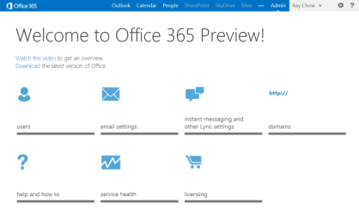
Office 365 is easy for anyone to manage.
Office 365 is now available to home as well as business and organizational users. Here are some of the features that are available to all Office 365 users.

Settings move with you
If you use Office a lot, you probably have things set up the way you like it — your Ribbon, your styles and other default settings. Even if you sign in to Office 365 on a different PC, everything will be ready for you to get to work right away.

Always have the latest innovations
Office is continually evolving. New and enhanced features and services are added all the time, and thanks to the cloud, Microsoft has greatly increased the pace of innovation. Because Office 365 is a subscription service, you always have the most up to date Office at your fingertips. You get the latest ways to work as soon as they are available, automatically downloaded and synched with Office on your desktop. With the subscription service, there’s no need to buy a new edition or upgrade.

Stream Office to any Windows 7- or Windows 8-based PC with Office on Demand
Ever wanted to get something done on a PC that’s not your own? With an Office 365 subscription you can. You don’t even have to have Office installed on the PC. Stream a full-featured Office application to any Internet-connected PC running Windows 7 or Windows 8 using Office on Demand. When you’re done, close the application and it will be removed from the PC.

Connect to social networks easily
Bring your online social networks to Office, complete with pictures, contact information and status updates. Rekindle old connections, ask questions, boost your business and more. It’s all possible with the latest version of Office, which includes built-in connectors that bring LinkedIn and Facebook into more of your Office experience.

Office 365 Home Premium and SkyDrive: any file, anywhere, automatically
You want to access and share your documents and other files, but you don’t always have your PC with you. No problem — when you are signed in, Office 365 Home Premium saves your documents to SkyDrive by default. You can access them from any Internet-connected device. Want to save them to your local drive? You can do that, too. (Office 365 editions for business use SharePoint for document sharing, storage and collaboration. For more information, see the section on Office 365 for businesses.)
With your documents stored on SkyDrive, you have what you need wherever you go — whether it’s a home to-do list or the latest version of a sales presentation. Putting your files on SkyDrive has other benefits, too. For one thing, they aren’t stored on a PC hard drive with a limited lifespan. If your computer goes down, your files stay up. And, if you’re collaborating with other people, you only have to keep track of one version instead of sending revisions back and forth by email. Going mobile? Access your SkyDrive files quickly and easily from your smartphone. Use the SkyDrive apps for Windows Phone and other compatible mobile phones, or just sign in from your browser. Either way, you’ll get your docs to go.
Accelerate your creative process with collaboration built in. With Office 365 Home Premium and SkyDrive, people can work together even when they’re not together. Work on a vacation plan in OneNote with a family member. Post it on SkyDrive and invite others to review and do basic editing in their browser with the free Office Web Apps. They don’t have to have Office installed to get a great experience.

Office 365 for businesses: turbocharge your productivity
Office 365 for businesses gives your business the productivity tools it needs to succeed in a fast-moving world. With up-to-date Office applications for Windows-based PCs, tablets and mobile phones, you can keep things moving forward from anywhere. Powerful, easy-to-manage online services including Exchange, SharePoint and Lync give any business enterprise-grade capabilities. Plans are available to suit organizations of all sizes. Best of all, you don’t have to deploy or manage servers on site, and Microsoft provides a 99.99 percent financially backed uptime guarantee for Office 365 services.

Keep people connected
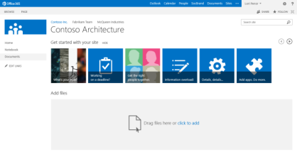
Easily create SharePoint Team Sites with built-in guidance.
Office 365 for businesses helps you stay connected with new tools such as high-definition, multiparty videoconferencing in Lync, SharePoint Team Sites to keep team communications and documents in a single place, and newsfeeds to follow sites, documents and discussions to get answers in real time.
With SharePoint, Office 365 delivers business-centric social networking designed to help people stay connected and innovate together. You can follow people, teams, documents and sites to stay on top of the latest happenings. Keep track of what your colleagues are up to through their activity feed. SharePoint even recommends people and documents to follow based on your interests and responsibilities. Ratings and reputation scores enable you to recognize colleagues and develop expert communities.
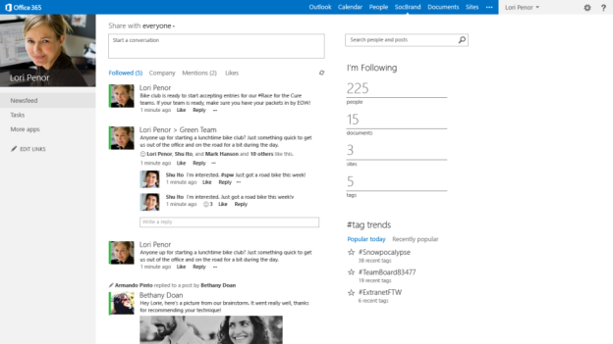
Enterprise social networking with SharePoint

Email, contacts, calendars everywhere
The more places you can access email, the faster your business can move. Office 365 gives you the power of Exchange, the world’s most used email server, in a hosted service that is easy enough for even solo professionals and small businesses but powerful enough for the largest enterprise organizations. Exchange helps protect your email and data with powerful anti-spam and anti-malware services that are always up to date, as well as policy-based information protection.
Now you can take enterprise-grade email with you anywhere. The improved Outlook Web App works on all major browsers and is optimized for touch navigation. And with Exchange ActiveSync, users can get email, contacts, calendars and tasks on a wide variety of mobile devices.

Work together across your business
Office 365 for businesses keeps everyone in your organization connected no matter where they are. Find the expertise you need with a SharePoint search. Detailed contact cards and presence, now integrated into all Office applications, help you connect and work with people from anywhere within the Office experience. When you find who you’re looking for, join in rich, interactive discussions and meetings with audio, video and instant messaging (IM) capabilities of Lync. You can start the conversation spontaneously by hopping from IM to voice to video, or send out online meeting invitations with a couple of clicks.

Share ideas and content
SharePoint helps you keep track of what your colleagues are doing by following people, sites and documents. You can get instant feedback on the documents and projects you’re working on delivered in real time to your activity feed. Sharing documents or presentations with the people you work with should be simple, intuitive and always available. With SkyDrive Pro you can share content with the people you work with without leaving your document library and track who you’re sharing with at a glance. You can publish and share documents directly to SharePoint from any Office application via the Office Backstage View. When you need to work with colleagues, you can co-author documents in the browser using Office Web Apps.

Keep teams in sync
Prescriptive guidance is now built right into SharePoint. It guides you through setting permissions, creating document libraries, and adding a custom theme to your site so you can quickly set up a new team site. You can even provide external partners and vendors access to SharePoint sites or documents with robust security while helping to meet the data governance and protection policies set by your IT department. To help your team stay in sync, all your team documents and emails can be accessible from Outlook and SharePoint using a Site Mailbox.

Gain insights anywhere with Excel and SharePoint
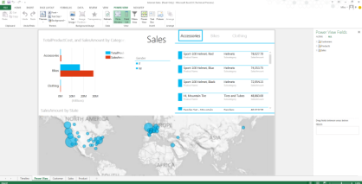
With PowerView you can see actionable data at a glance.
Empower everyone in your organization to gain business insights. Mash up big data from multiple sources using PowerPivot. Explore data, visualize it and tell a compelling story using PowerView. When it’s decision time, share business intelligence-enriched reports and dashboards with SharePoint to give everyone access to the real numbers.

Deploy it your way
The cloud is the future of Office, but you can go there at your own pace. Not only can you install Exchange, SharePoint or Lync in your own datacenter, the latest releases of Office servers are built on the very same technology that powers Office 365. That means you can keep some users on-premises while others consume services from the cloud. Move to the cloud at your own pace. Test different configurations before deploying. Keep sensitive data within your firewall. Whatever the reason, it’s your Office — deploy it how you want to. And, you can even still get traditional, perpetual Office client licenses to install on desktops and PCs in your organization.

