Home
WordHost
One minute free build and publish professional and stunning website
No codes, no drag, no drop just upload Microsoft Word, you can create professional and stunning websites.
Sanwhole WordHost let you create websites via Microsoft Office Word files. You don’t have to learn website coding technical, you even don’t have to drag and drop online to create your website. Just create a Microsoft Office Word document offline and upload via your account. Your website is ready! At least seconds, at most minutes, you let the whole world can reach to you!
If you know website coding, you must know how hard to integrate a simple table into web page. You do not even have to expect to add a nice histogram to your web page. Now, you can have Microsoft Office Word beautiful and professional features in your websites such as professional tables, Shapes, Clip Art, Chart, SmartArt, WordArt etc.
Website backup and restore is hard and sometime even impossible. You don’t have to do it anymore when you use WordHost service. Because you backup your Word files you backup your websites. You upload your Word files, you restore your websites.
You don’t have to edit your website online. Modify your Word files offline and upload; you complete your websites modification. Even if your network faster, even if you drag and drop easier, and cannot be compared with the offline local editor – Microsoft Office Word.
WordHost can create heavy loaded websites, can build a thousand pages with ease such as heavy online help website.
And more, WordHost let you integrate online resources into website, such as YouTube, Vimeo video, MP4 video. You may integrate Disqus and other website tools in your website as well.
You may create one website for free.
WordHost Tree Website
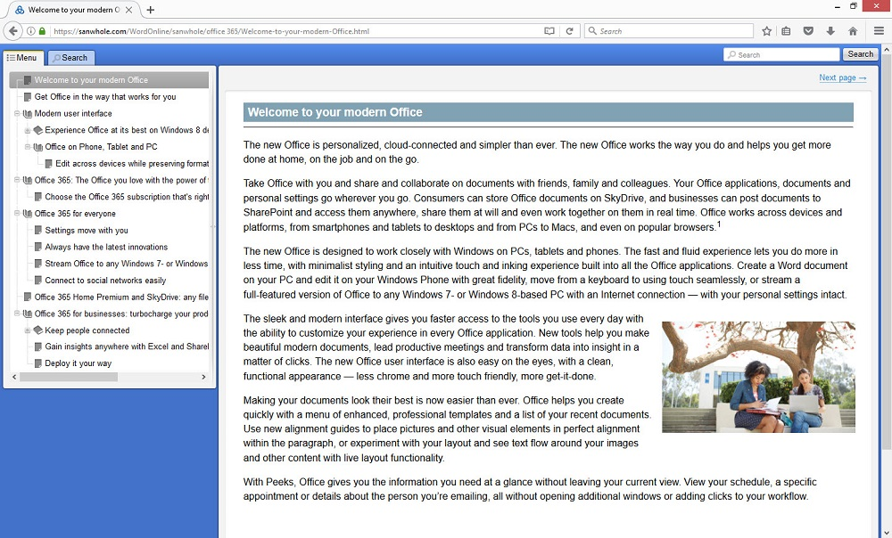

WordHost Tree Website Search
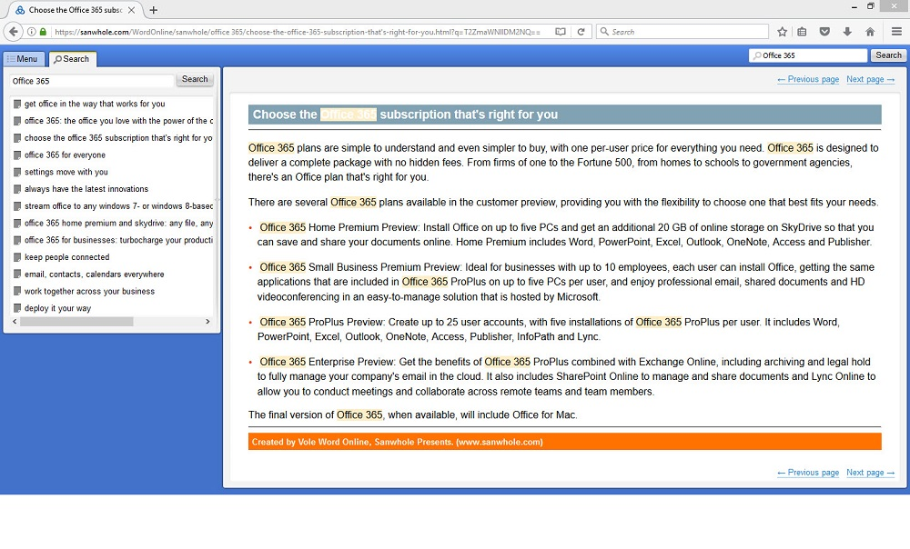

View Document Online Comparison Table
 | WordHost | View Adobe PDF Online | Microsoft View Word Online
Online
Supports multiple browsers
Topic Tree (Bookmarks) |  |  | -
Integrate Rich Media, such as YouTube, Vimeo, MP4 etc.
Support mobile devices
Each document is a unique website |  | - | -
Support customize domain |  | - | -
Can share every page |  | - | -
Each page indexed by search engine |  | - | -
See which page, load which page |  | - | -
Search result list base on pages |  | - | -
Integrate HTML code |  | - | -
Integrate online comment, chat and other tools, such as Diqus, Zopim etc. |  | - | -
Live Examples | Sanwhole | Adobe | Microsoft

Website Hosting Comparison Table
 | WordHost | Weebly and Wix | ASP.NET and PHP
No ASP.NET, PHP or HTML Coding |  |  | -
Easily play rich media such as MP4, YouTube, Vimeo etc. |  |  | -
Customized Domain
Embed HTML code
Integrate Comment, Chat etc web tools such as Disqus, Zopim etc.
Simple Table |  | Need extra app
Professional Table |  | - | -
Rich Beautiful Table Template |  | - | -
Word Shapes |  | - | -
Word Clip Art |  | - | -
Word Chart |  | - | -
Word SmartArt |  | - | -
WordArt |  | - | -
Automatically Topic Tree Menu |  | - | -
Automatically Prev and Next Page |  | - | -
Website Offline Edition |  | -
Fully Website Backup |  | -
Use Backup Restore Website |  | -
Search result list base on pages |  | - | -

Online Resources Integrated
Want integrate YouTube, Vimeo, play your MP4? Want to integrate Disqus? Yes, you can.
You may add Sanwhole Word Command to your Word document via free Sanwhole Word Command Creator. Then your website can have it.
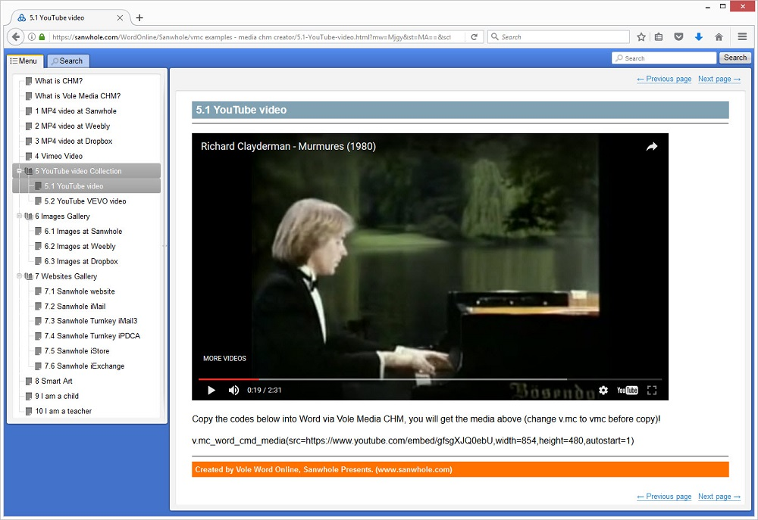

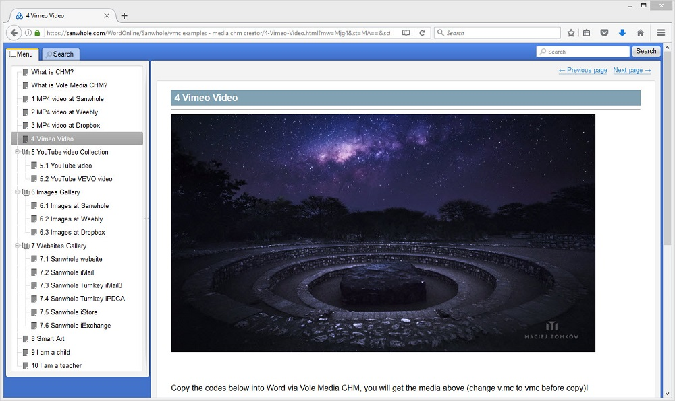
User Domain and Full Unicode supports
WordHost supports user domain. Your default website address begins with https://sanwhole.com/WordOnline/YourRootName. You can change the default address to your domain address. You may see the image below for detail.
WordHost fully supports Unicode. WordHost can build your native language website with ease.
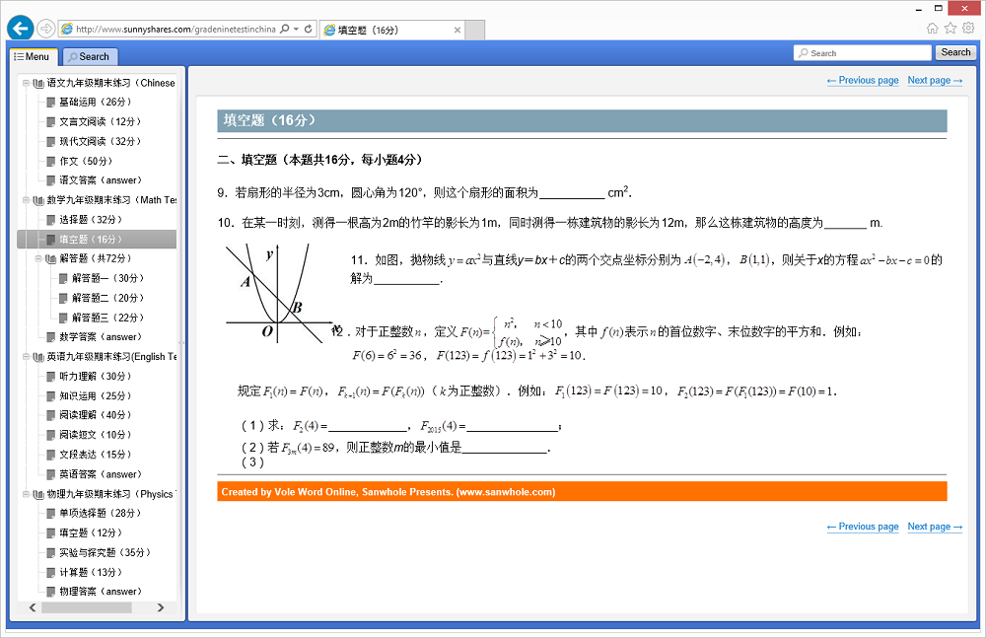
Full web-access management
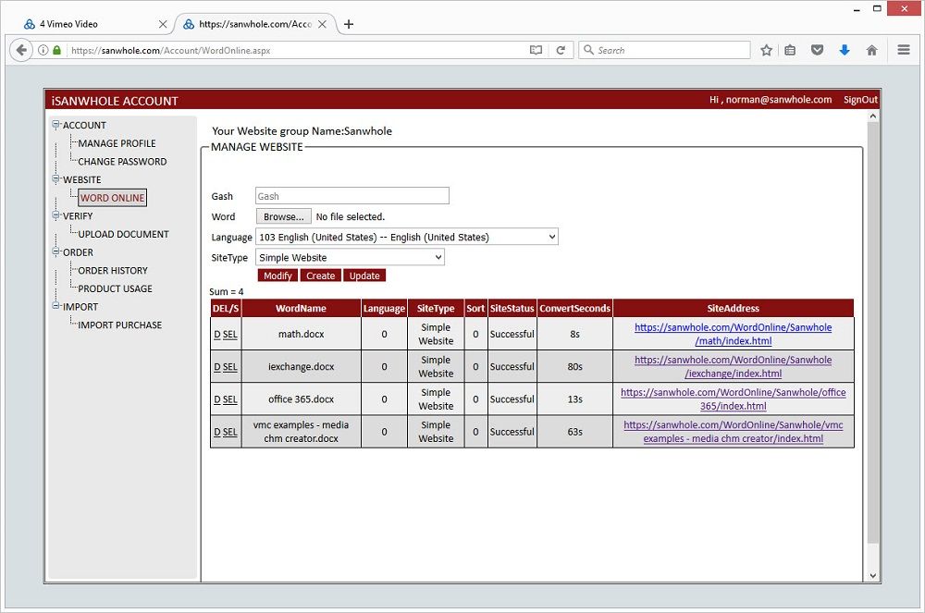
Classic Experience Video - YouTube
vmc_word_cmd_media(src=https://www.youtube.com/embed/1f8c9EyfVN8, width=1000, height=562,autostart=0)

Classic Experience Video – Sanwhole
vmc_word_cmd_media(src=https://sanwhole.com/media/word_online_service_classic_experience.mp4, width=854, height=480,aspectratio=16:10)

PLANS | 1 website | 2 websites | 5 websites | 10 websites | 30 websites | 100 websites
Price | Free | $1.00/month  $36.00/3-year | $4.00/month  $40.00/year | $6.00/month  $60.00/year | $12.00/month  $120.00/year | $30.00/month  $300.00/year
Max Word / Total Size | 1M / 1M | 3M / 6M | 5M / 15M | 5M / 30M | 10M / 90M | 10M / 300M
User Domain
Other Features
Unlimited Traffic

FAQ
How to Build website via WordHost Service? | Click here.
How to redeem purchase code? | Click here.

Online Media

MP4 video at Sanwhole
vmc_word_cmd_media(src=http://www.sanwhole.com/media/Knight%20and%20Day%20-%20Official%20Trailer%20%28HD%29%20-%2020th%20Century%20FOX.mp4,aspectratio=16:9,autostart=true)

MP4 video at Weebly
vmc_word_cmd_media(src=http://www.weebly.com/uploads/6/7/0/7/6707420/the_next_three_days_movie_trailer_official__hd_.mp4,aspectratio=16:9,autostart=true)

MP4 video at Dropbox
vmc_word_cmd_media(src=https://www.dropbox.com/s/ht3rk542mpeptix/Zootopia%20Official%20Sloth%20Trailer%20%282016%29%20-%20Disney%20Animated%20Movie%20HD.mp4?raw=1,aspectratio=16:9,autostart=true)

Images at Sanwhole
vmc_word_cmd_media(src=http://www.sanwhole.com/images/squirrel.jpg, width=512, height=361) | vmc_word_cmd_media(src=http://www.sanwhole.com/images/sunrise.jpg, width=512, height=361)
vmc_word_cmd_media(src=http://www.sanwhole.com/images/vwe.jpg, width=512, height=361) | vmc_word_cmd_media(src=http://www.sanwhole.com/images/mountain.jpg, width=512, height=361)
vmc_word_cmd_media(src=http://www.sanwhole.com/images/dog.jpg, width=512, height=361) | vmc_word_cmd_media(src=http://www.sanwhole.com/images/duck.jpg, width=512, height=361)
vmc_word_cmd_media(src=http://www.sanwhole.com/images/jellyfish.jpg, width=512, height=361) | vmc_word_cmd_media(src=http://www.sanwhole.com/images/crab.jpg, width=512, height=361)

Images at Weebly
vmc_word_cmd_media(src=http://www.weebly.com/uploads/6/7/0/7/6707420/squirrel.jpg, width=512, height=361) | vmc_word_cmd_media(src=http://www.weebly.com/uploads/6/7/0/7/6707420/sunrise.jpg, width=512, height=361)
vmc_word_cmd_media(src=http://www.weebly.com/uploads/6/7/0/7/6707420/vwe.jpg, width=512, height=361) | vmc_word_cmd_media(src=http://www.weebly.com/uploads/6/7/0/7/6707420/mountain.jpg, width=512, height=361)
vmc_word_cmd_media(src=http://www.weebly.com/uploads/6/7/0/7/6707420/dog.jpg, width=512, height=361) | vmc_word_cmd_media(src=http://www.weebly.com/uploads/6/7/0/7/6707420/duck.jpg, width=512, height=361)
vmc_word_cmd_media(src=http://www.weebly.com/uploads/6/7/0/7/6707420/jellyfish.jpg, width=512, height=361) | vmc_word_cmd_media(src=http://www.weebly.com/uploads/6/7/0/7/6707420/crab.jpg, width=512, height=361)

Images at Dropbox
vmc_word_cmd_media(src=https://www.dropbox.com/s/j0ogh7vw0iohig8/Squirrel.jpg?raw=1, width=512, height=361) | vmc_word_cmd_media(src=https://www.dropbox.com/s/7785dthdorpp7d0/Sunrise.jpg?raw=1, width=512, height=361)
vmc_word_cmd_media(src= https://www.dropbox.com/s/rtwj74s5yy1yq0i/VWE.jpg?raw=1, width=512, height=361) | vmc_word_cmd_media(src=https://www.dropbox.com/s/qrxcfourtxr0jq9/Mountain.jpg?raw=1, width=512, height=361)
vmc_word_cmd_media(src=https://www.dropbox.com/s/loqwwawy9vel751/Dog.jpg?raw=1, width=512, height=361) | vmc_word_cmd_media(src=https://www.dropbox.com/s/61z2n8hnx7gbeee/Duck.jpg?raw=1, width=512, height=361)
vmc_word_cmd_media(src=https://www.dropbox.com/s/wob7tku020rmqlc/Jellyfish.jpg?raw=1, width=512, height=361) | vmc_word_cmd_media(src=https://www.dropbox.com/s/35v279q1wdyakkr/Crab.JPG?raw=1, width=512, height=361)

Social Video

YouTube
vmc_word_cmd_media(src=https://www.youtube.com/embed/IyzY5kKzfFM,width=854,height=480,autostart=1)

Vimeo
vmc_word_cmd_code(P A B p A G Y A c g B h A G 0 A Z Q A g A H M A c g B j A D 0 A I g B o A H Q A d A B w A H M A O g A v A C 8 A c A B s A G E A e Q B l A H I A L g B 2 A G k A b Q B l A G 8 A L g B j A G 8 A b Q A v A H Y A a Q B k A G U A b w A v A D E A N Q A 2 A D E A N g A w A D U A N A A 0 A D 8 A Y Q B 1 A H Q A b w B w A G w A Y Q B 5 A D 0 A M Q A m A H Q A a Q B 0 A G w A Z Q A 9 A D A A J g B i A H k A b A B p A G 4 A Z Q A 9 A D A A J g B w A G 8 A c g B 0 A H I A Y Q B p A H Q A P Q A w A C I A I A B 3 A G k A Z A B 0 A G g A P Q A i A D g A N Q A 0 A C I A I A B o A G U A a Q B n A G g A d A A 9 A C I A N A A 4 A D A A I g A g A G Y A c g B h A G 0 A Z Q B i A G 8 A c g B k A G U A c g A 9 A C I A M A A i A C A A d w B l A G I A a w B p A H Q A Y Q B s A G w A b w B 3 A G Y A d Q B s A G w A c w B j A H I A Z Q B l A G 4 A I A B t A G 8 A e g B h A G w A b A B v A H c A Z g B 1 A G w A b A B z A G M A c g B l A G U A b g A g A G E A b A B s A G 8 A d w B m A H U A b A B s A H M A Y w B y A G U A Z Q B u A D 4 A P A A v A G k A Z g B y A G E A b Q B l A D 4 A)

Websites Gallery

Sanwhole website
vmc_word_cmd_iframe(src=https://www.sanwhole.com/,width=1180,height=750)

Sanwhole iMail
vmc_word_cmd_iframe(src=https://sanwhole.com/Products/iMail,width=1180,height=750)

Sanwhole iStore
vmc_word_cmd_iframe(src=https://www.sanwhole.com/istore/home.aspx,width=1180,height=750)

Sanwhole iExchange
vmc_word_cmd_iframe(src=https://www.sanwhole.com/iexchange/home.aspx,width=1180,height=750)

Word Online

Smart Art
Hello Sanwhole Vole Multimedia Based CHM!

Professional Table
 | WordHost | Weebly and Wix | ASP.NET and PHP
No ASP.NET, PHP or HTML Coding |  |  | -
Easily play rich media such as MP4, YouTube, Vimeo etc. |  |  | -
Customized Domain
Embed HTML code
Integrate Comment, Chat etc web tools such as Disqus, Zopim etc.
Simple Table |  | Need extra app
Professional Table |  | - | -
Rich Beautiful Table Template |  | - | -
Word Shapes |  | - | -
Word Clip Art |  | - | -
Word Chart |  | - | -
Word SmartArt |  | - | -
WordArt |  | - | -
Automatically Topic Tree Menu |  | - | -
Automatically Prev and Next Page |  | - | -
Website Offline Edition |  | -
Fully Website Backup |  | -
Use Backup Restore Website |  | -
Search result list base on pages |  | - | -

