vmc_word_cmd_center

vmc_word_cmd_setting
///Site setting
vwcs_ShowCmdInOutput=0 ///1=show 0=hide; Show or hide vmc_word_cmd_center in output.
vwcs_AutoMenu=0
vwcs_EmbedImage=0
vwcs_PageWebAddress:Home=index.html
vwcs_RemovePath=http://rmv/

vmc_word_cmd_block_FinePrint
SANWHOLE SOFTWARE LICENSES AGREEMENT
Last modification: 2020-05-22
SERVICE DURATION TYPE
AUTD | Always up to date.  Free minor update and major upgrade during subscription duration. Provide free edition features out of subscription duration.
LTUD | Life Time use + free 2 years major Upgrades.  From the date of purchase, you can get 2 years of free upgrade service. After that, the software can continue to be used, but will not be upgraded for free.
LTUG | Life Time use + free major Upgrades.  You can free upgrade to any version, just like you have bought all windows version at once, include Windows 7, Windows 8, Windows 10 etc.
LICENSES USAGE
Refund | Sanwhole software products support a 30-day paid try.  Once you have purchased and paid the full amount at Sanwhole, you can immediately download a 30-day temporary registration file.  Within 30 days, you decide to refund, we will deduct $1.00 and refund the balance to you.  Any time you decide not to refund, please let us know and you will be able to download the permanent registration file.  We give refunds only during 30 days after purchase.
License Usage | Each license allows installation on all your owned and you use computers and may be used at exactly the same time.  School license can be used for school only; only business, enterprise license can be used for business.  License may not be resold.  You only need to purchase one license per product for yourself.
License Transfer | You can transfer excess licenses to others. Sanwhole does not charge any fees.  For example, you purchased a Vole Windows Expedition license before, and then you purchased a Sanwhole Office license. So, you can log in to your Sanwhole account and transfer the Vole Windows Expedition license to someone else who only needs to register with Sanwhole.  For example, you purchased several licenses during the discount period. You can also use the same method to transfer excess licenses to others. We do not charge you or the other party any fees.  The license transfer is confidential for your original purchase price. That is, the other party does not see your original purchase price.
Activate | Set all licenses in one file (VoleLicenses.txt), easy activate and no online activated required.  After you purchase or redeem, you can immediately download a 30-day temporary registration file.  Your temporary license will be invalid after 30 days. You can download your formal license after 30 days for free if you want to continue use the software.  You can download your license file at any time and as many times as you want for free.  Tips: If activation fails during use, try downloading the license file and activating it again.
Renewal | AUTD edition renewal price is same with order price. LTUD and LTUG edition may be used indefinitely.
Support | Support is provided for the lifetime at Sanwhole Forums.
At Expiration | At subscription expiration (AUTD only), the applications enter a reduced-functionality mode, which means documents can be viewed but it isn’t possible to edit or create
LICENSES PROTECTION
In order to prevent your licenses not to be terminated due to piracy, we require users to use real full name registration. The software will display the license owner full name on the top of the software, for example: “Hi Norman Wong!”
Because using real full name registration, others dare not use your license and you will not use others. This protects us and protects you, too. We will stop the piracy license even if it is yours.
We've handled thousands of PayPal users. Your information is safe.

vmc_word_cmd_block_header

vmc_word_cmd_block_footer
See also:
- SWOTE - Sanwhole Online Traditional Education
- iSchool Self-Managed Online Traditional School
- iOffice Self-Managed Online Tranditional Office
- Sanwhole Office

Built by Vole PageShare 5.19.20096, Sanwhole Presents. (www.sanwhole.com)
Create professional stunning websites via built-in Word editor and enjoy Microsoft Office user experience.

vmc_word_cmd_block_experiences_and_diy

EXPERIENCES AND DIY
VPS_CMD_TREE
- Vole Internet Expedition
Vole Internet Expedition, Edge, Chrome and Firefox Speed Test
video

  - Vole Internet Expedition Classic Experiences 64-bit
Vole Internet Expedition Classic Experiences 64-bit
2020-03-12
video

  - Vole Internet Expedition Classic Experiences 32-bit
Vole Internet Expedition Classic Experiences 32-bit
2020-03-12
video

  - How to Use Vole Internet Expedition
How to Use Vole Internet Expedition
2019-02-01
video

  - Vole Internet Expedition Scene Manager
Vole Internet Expedition Scene Manager
2014-06-27
video

- Vole Windows Expedition

  - Vole Windows Expedition Classic Experiences
Vole Windows Expedition Classic Experiences
2015-02-07
video

  - Add Watermark to Image
Add Watermark to Image
2018-06-29
video

  - Add GIF and Lyrics to Music
Add GIF and Lyrics to Music
2018-06-28
video

  - Create GIF Animation
Create GIF Animation
2018-06-29
video

- Vole Word and Excel

  - Vole Word and Excel Classic Experiences
Vole Word and Excel Classic Experiences
2018-09-01
video

- Vole Briefcase

  - Vole Briefcase Classic Experiences and DIY
Vole Briefcase Classic Experiences and DIY
2020-08-27
video

  - Vole Briefcase Classic Experience - Presentation
Vole Briefcase Classic Experience - Presentation
2020-08-30
video

  - Vole Briefcase Classic Experiences - Presentation DIY
Vole Briefcase Classic Experiences - Presentation DIY
2020-08-30
video

  - How To Use Advanced Accordion Control
How To Use Advanced Accordion Control
2020-11-21
video

  - How To Use Advanced Tree Control
How To Use Advanced Tree Control
2020-11-21
video

  - How To Use Advanced Table Control
How To Use Advanced Table Control
2020-11-21
video

- Vole Edutainment

  - Vole Edutainment Classic Experience
Vole Edutainment Classic Experience
2014-08-21
video

  - Vole Edutainment DIY
Vole Edutainment DIY
2014-08-21
video

- Vole Magic Note

  - Vole Magic Note Tutorial
Vole Magic Note Tutorial
2020-05-05
video

  - Vole Magic Note Classic Experience
Vole Magic Note Classic Experience
2016-09-20
video

- Vole Remember

  - Vole Remember Classic Experience
Vole Remember Classic Experience
2014-07-08
video

  - Vole Remember DIY
Vole Remember DIY
2014-07-08
video

- Vole PageShare

  - Vole PageShare Create and Publish Website with Ease
Vole PageShare Create and Publish Website with Ease
2018-12-15
video

  - How To Use Advanced Accordion Control
How To Use Advanced Accordion Control
2020-11-21
video

  - How To Use Advanced Tree Control
How To Use Advanced Tree Control
2020-11-21
video

  - How To Use Advanced Table Control
How To Use Advanced Table Control
2020-11-21
video

  - Using Online Templates To Jump-Start Your Project
Using Online Templates To Jump-Start Your Project
2018-12-12
video

  - How to Publish Your Website to Online
How to Publish Your Website to Online
2018-03-10
video

  - How to Share Files on Sanwhole PageShare Cloud
How to Share Files on Sanwhole PageShare Cloud
2018-12-15
video

  - Sanwhole PageShare Let Your Website Integrate Web Games With Ease
Sanwhole PageShare Let Your Website Integrate Web Games With Ease
2018-03-07
video

- Vole PDF Creator

  - Vole PDF Creator Tutorial
Vole PDF Creator Tutorial
2018-11-07
video

- Vole Media CHM

  - Use Vole Media CHM Basically
Use Vole Media CHM Basically
2019-01-31
video

  - Use Vole Media CHM Professionally
Use Vole Media CHM Professionally
2019-02-01
video

  - How To Use Advanced Accordion Control
How To Use Advanced Accordion Control
2020-11-21
video

  - How To Use Advanced Tree Control
How To Use Advanced Tree Control
2020-11-21
video

  - How To Use Advanced Table Control
How To Use Advanced Table Control
2020-11-21
video

- Vole Word Reviewer

  - Vole Word Reviewer Classic Experience
Vole Word Reviewer Classic Experience
2015-02-17
video

- Vole CHM Reviewer

  - Vole CHM Reviewer Classic Experience
Vole CHM Reviewer Classic Experience
2015-02-01
video

  - Vole CHM Reviewer DIY
Vole CHM Reviewer DIY
2015-02-16
video

- Vole PDCA

- iMail

  - iMail Internal Users
iMail Internal Users
2018-11-06
video

  - iMail Internal Users Out of Office
iMail Internal Users Out of Office
2018-11-14
video

  - iMail Out of Office with Gmail
iMail Out of Office with Gmail
2018-11-14
video

  - iMail In the Office with Hotmail
iMail In the Office with Hotmail
2018-11-14
video

- iSchool

  - iSchool Classic Experience
iSchool Classic Experience
2020-06-18
video

  - iSchool Classic Experience - Math Exam
iSchool Classic Experience - Math Exam
2020-06-24
video

  - iSchool Classic Experience – Music Homework
iSchool Classic Experience – Music Homework
2020-06-22
video

  - iSchool Classic Experience – Art Homework
iSchool Classic Experience – Art Homework
2020-06-24
video

- iOffice

- Exchange Server

  - Exchange Server Install and Setup (LAN)
Exchange Server Install and Setup (LAN)
2020-05-31
video

- Railway Signal

  - Railway Signal Experience Center
Railway Signal Experience Center
2019-06-22
video

  - Internet Computer Interlocking Classic Experience
Internet Computer Interlocking Classic Experience
2019-06-22
video

- Placeholder Designer

  - How To Use Advanced Accordion Control
How To Use Advanced Accordion Control
2020-11-21
video

  - How To Use Advanced Tree Control
How To Use Advanced Tree Control
2020-11-21
video

  - How To Use Advanced Table Control
How To Use Advanced Table Control
2020-11-21
video

  - Online Examples and Template

    - Using Online Template to Jump-start Your Project
Using Online Template to Jump-start Your Project
2019-05-31
video

  - PageShare Cloud Hosting

    - How to Share on Sanwhole Cloud
How to share your files on Sanwhole PageShare Cloud up to 1050 MB for free?
2020-02-28
video

- Sales

  - Redeem and Activate
How to Redeem and Activate
2020-02-25
page

vmc_word_cmd_block_product_tempalte_faqs

FAQs
VPS_CMD_TREE
- Requirement

REQUIREMENT
Operating System: Windows 7, 8.1, 10. 32-bit&64-bit
.NET Framework: 4.5.2.

- Download
Download
You can download the latest software here.

- Purchase
Purchase
You can purchase the software licenses here.

- Activate
Activate
You can get the software activation instructions here.

- Feedback
Feedback
You can leave your comments here.

- Agreement
Agreement
vmc_word_cmd_block_FinePrint

vmc_word_cmd_block_product_tempalte_gethelp

GET HELP
VPS_CMD_TREE
- Get Started
Get Started
Watching video tutorials is the best way to start using Sanwhole software.
Tutorial videos include the Experience sections and the DIY sections. The Experience sections teach you what it can do, and the DIY sections teach you how to do it step by step. These tutorial videos can help you create projects as beautiful as our examples. Learning to use our software is much less hard than learning Microsoft Office Word, but it still takes you to be serious, confident and patient. You can get the tutorial video on the software home page.

- Watch Other Software Tutorial Videos
Watch Other Software Tutorial Videos
All Sanwhole software support VMC, so more than 80% of operations are identical. Each time we upgrade VMC, we can only make one software VMC upgrade tutorial video. Therefore, you may not be able to find the corresponding tutorial video in the software home page you are interested in.
Please find and watch tutorial videos in EXPERIENCES AND DIY table above.

- Online Examples and Templates
Online Examples and Templates
Using the examples in the tutorial video is the best way to start trying to use the software. But due to file size limitations, we did not add all examples and templates to the installation file.
You can download the latest examples and templates here.

- Forum
Forum
Special questions are welcome to come to Sanwhole forum and we or others will reply to you.

- User Guide
User Guide
You can get online user guide, PDF and CHM help documents at USER GUIDE table in the software home page.

- Online Public Class
Online Public Class
Thanks to Google Meet, we can now teach in online as long as you have a Google account.
Through Google meet, we can teach you how to use our software through online chat, voice and shared desktop. We do not have customer service staff. The people who help you are our first-line software senior engineers.
The service is charged.

- One to One Teaching
One to One
Thanks to Google Meet, we can now teach one-on-one online as long as you have a Google account.
Through Google meet, we can teach you how to use our software one-on-one through online chat, voice and shared desktop. We do not have customer service staff. The people who help you are our first-line software senior engineers.
The service is charged.

Vole Windows Expedition
vmc_word_cmd_block_header
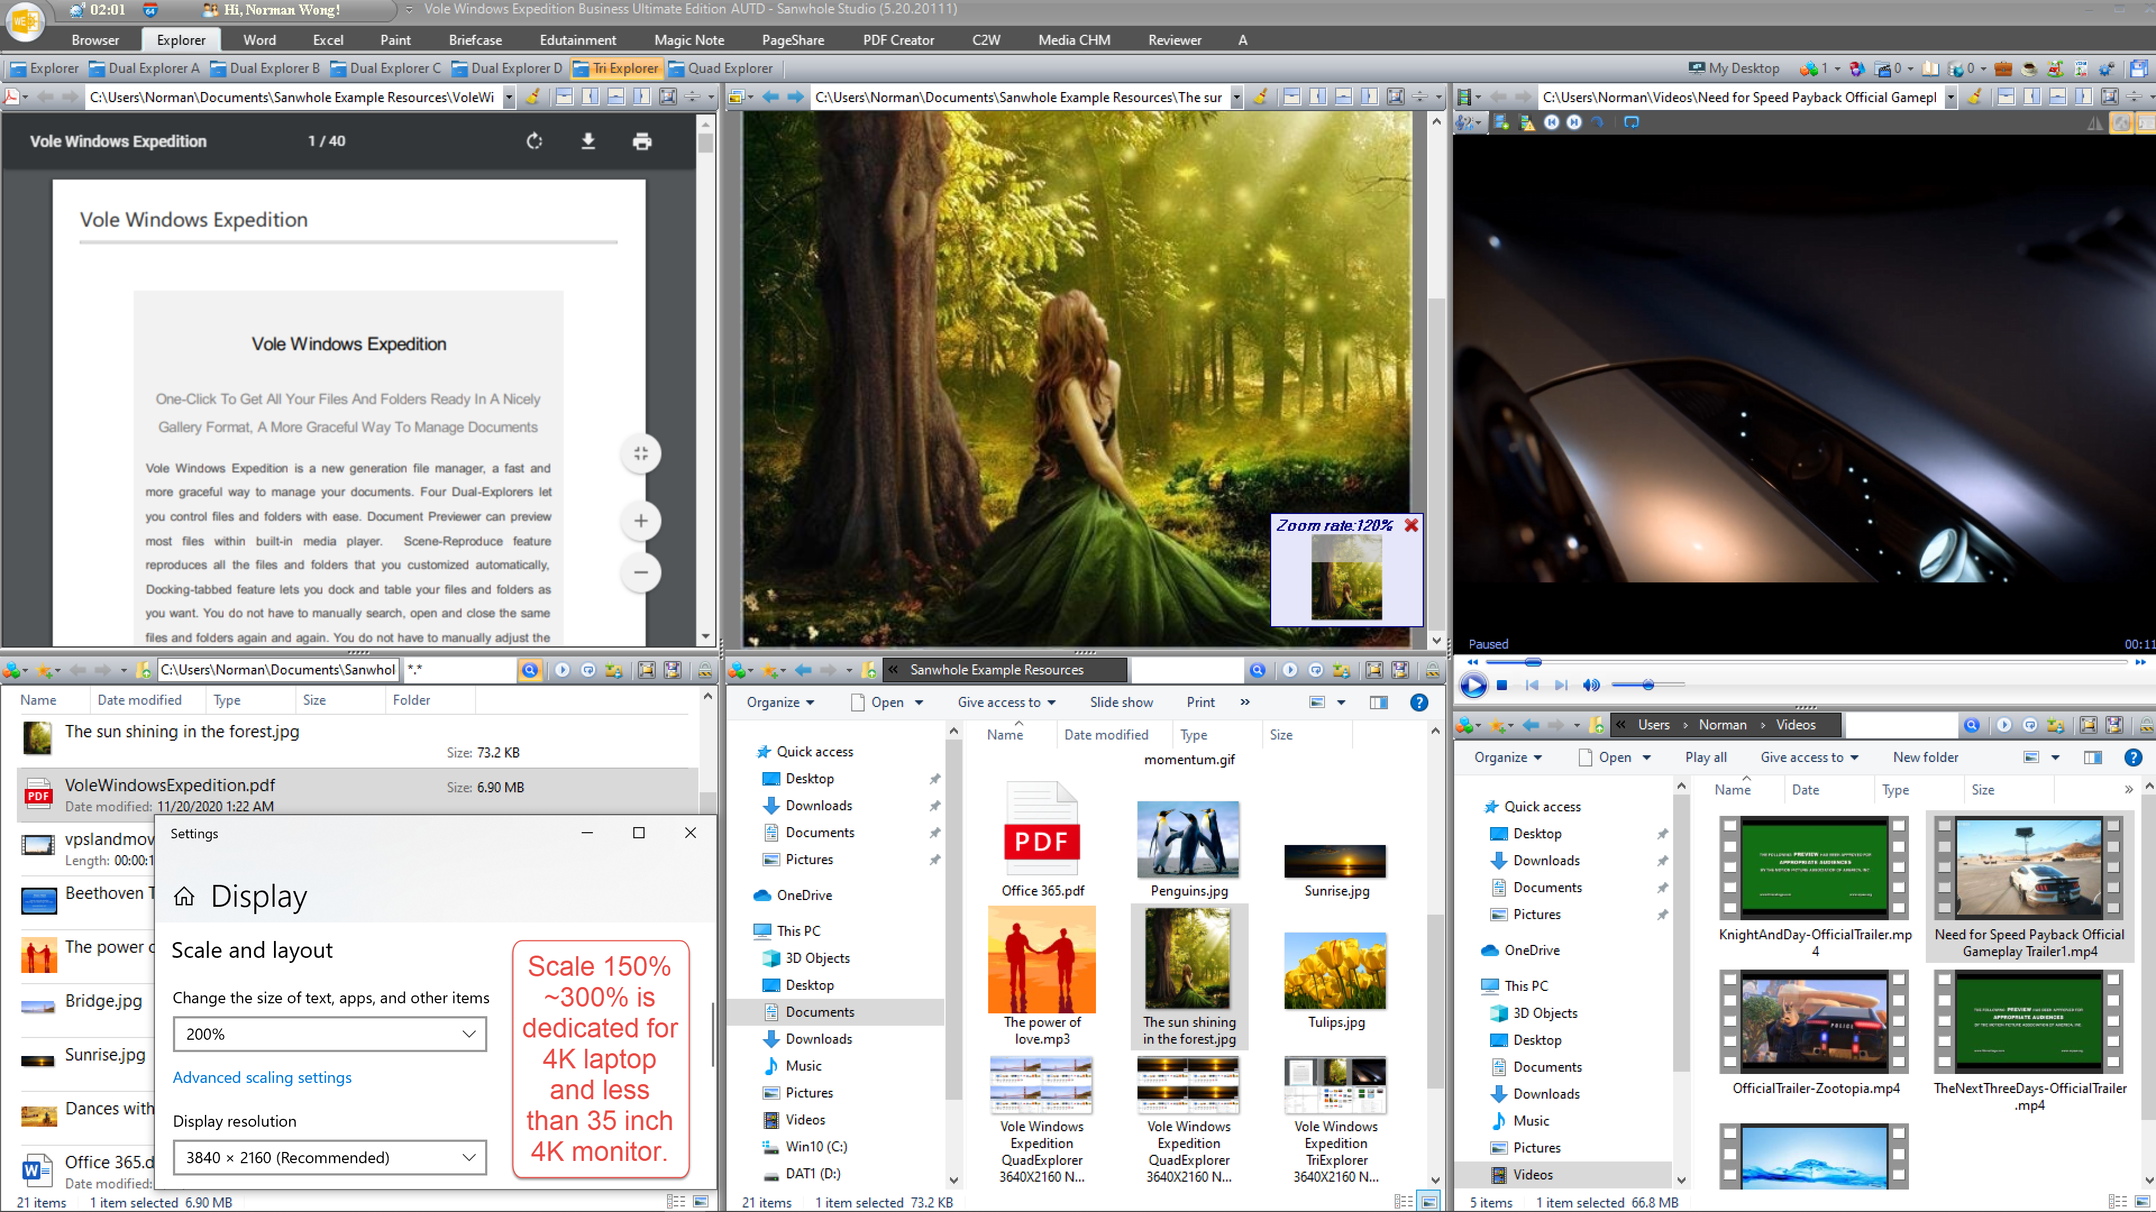

Vole Windows Expedition
One-Click To Get All Your Files And Folders Ready In A Nicely Gallery Format, A More Graceful Way To Manage Documents
Vole Windows Expedition is a new generation file manager, a fast and more graceful way to manage your documents. Four Dual-Explorers let you control files and folders with ease. Document Previewer can preview most files within built-in media player. Scene-Reproduce feature reproduces all the files and folders that you customized automatically, Docking-tabbed feature lets you dock and table your files and folders as you want. You do not have to manually search, open and close the same files and folders again and again. You do not have to manually adjust the files and folders docking and table position again and again. So have a cup of coffee, open the software lets Vole Windows Expedition do all for you, it will save much time for you every day.
Vole Windows Expedition supports 4K / 2K / 1K HD display. Tri and Quad browsers will bring you a better experience under the HD monitor. Vole Windows Expedition also supports display scaling, which is particularly important for 4K laptops. Scale 150%~300% is dedicated for 4K laptop and less than 35 inch 4K monitor.

FEATURES
Dual, Tri, Quad File Explorers
Dual, Tri and Quad full functional Windows file explorer
Vole Windows Expedition dual explorer is a combination of two Windows file explorer. Each explorer is a full function fully compatible Windows file explorer. You can display the explorers in vertical or horizontal and you can prominent each explorer via one click.

Dual File Explorers

Tri File Explorers

Vole Windows Expedition supports 4K / 2K / 1K HD display. Tri and Quad browsers will bring you a better experience under the HD monitor. Vole Windows Expedition also supports display scaling, which is particularly important for 4K laptops. Scale 150%~300% is dedicated for 4K laptop and less than 35 inch 4K monitor.

Quad File Explorers

Documents Previewer
Document Previewer lets you view a variety of resources in the built-in media player.
With Documents Previewer, you may preview images, audio, video, Microsoft Office Word, Excel, PDF, CHM, VMC, RTF, TXT, SWF, GIF, HTM, and HMT in the built-in media player. You can also preview online resources such as YouTube video, websites, webpage within VMC.

Scene-Reproduce
One-click operate, gets all files and folder within any scene ready automatically. Instant navigation and accurate position. Scene-Reproduce feature will automatically save the opened files and folder and their docking configuration to your local disk and will restore the opened files and folder same as saved when starts. And more, scene can be exported and imported. If you export your scene and import to as many as other computers, BOOM, all the other computers will open files and folders same as yours.
Docking-Tabbed
Docking-Tabbed is premium window control technology that lets you dock and table window as you want, Parallel, Vertical, Horizontal, Float, Horizontal Group, Vertical Group, Prominent, etc. This lets you view your web pages more convenient than ever. Most of the software you can imagine cannot provide this complicated feature, such as Windows, Office, iTunes, etc. Up to now, any other file managers don't have this feature.
Five-level Topology
Files and folders, categories, projects, scenes and scene manager five-level topology structure, the heaviest loaded file manager.
Color Themes
More than 15 beautiful featured themes relax your eyes; they are: Office 2007, Office 2010, Office 2013, Office 365 and Sparkle blue, silver, black, white color themes.

EXPERIENCES
Vole Windows Expedition Classic Experience

vmc_word_cmd_block_experiences_and_diy
vmc_word_cmd_block_product_tempalte_faqs
vmc_word_cmd_block_product_tempalte_gethelp

PLANS
PLAN | Free Edition | Professional Edition | Ultimate Edition | Summary
Document Previewer
Multi-Dual Explorers | - | 2 | 4
Scene Reproduce | - |  |  | Reproduces all the files and folders that you customized. Get all your files and folder ready automatically, a more graceful way to manage your documents.
Color Themes | 4 | 10 | All | Six beautiful color themes relax your eyes.
Max Pages in Category | Unlimited | Unlimited | Unlimited | A category is a general files and folders table can include as many files and folders as you want.
Max Categories in Project | 2 | Unlimited | Unlimited | A project can have several categories. You can use the seven preset categories or renew them as you want.
Max Projects in Scene | 2 | 10 | 20 | A scene can have several projects.
Max Scenes in Manager | 2 | 10 | 20 | You can manage several scenes via scene manager.
Music Mate | - | Cover + GIF | Cover + GIF + LRC
Magic GIF | - | + Note | + Note + Index
Images Watermark | - | IMG + TXT | Folder + IMG + TXT

vmc_word_cmd_block_footer

Vole Windows Expedition Interface

Interface
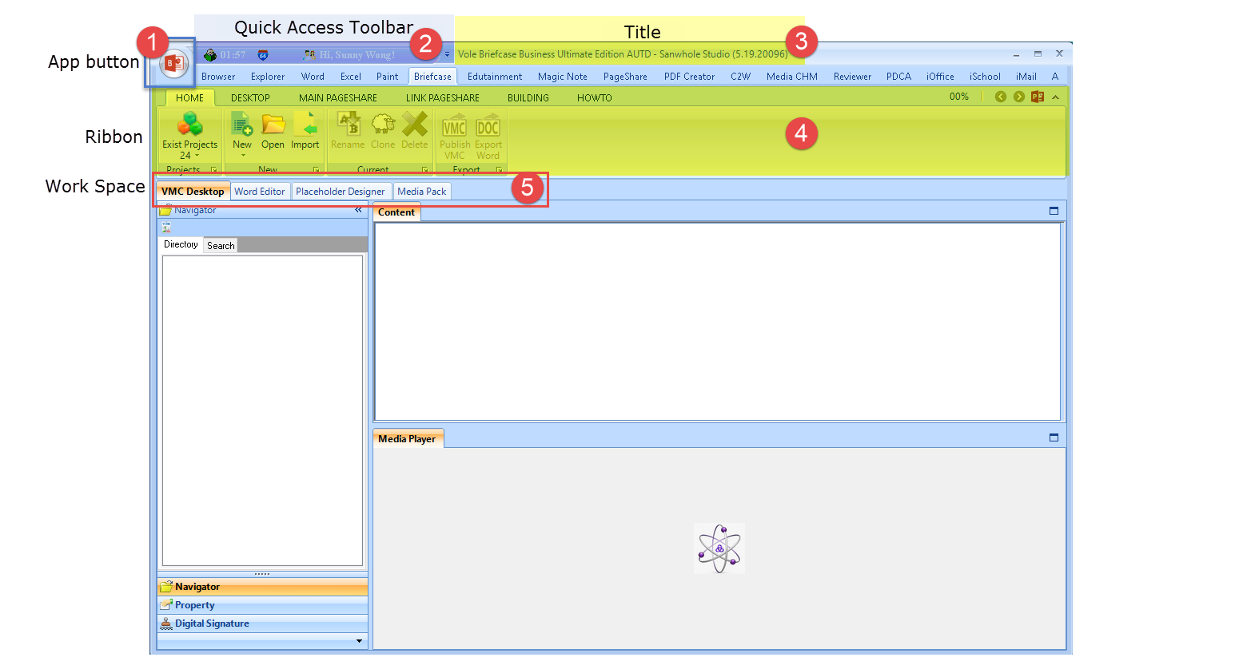
- App button (Application)
- Quick Access Toolbar
- Title
- Ribbon
- Work Space

Application
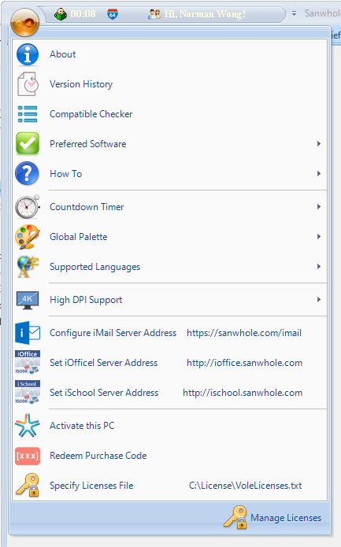

About

Version History
You can find all Sanwhole Software version history at here.
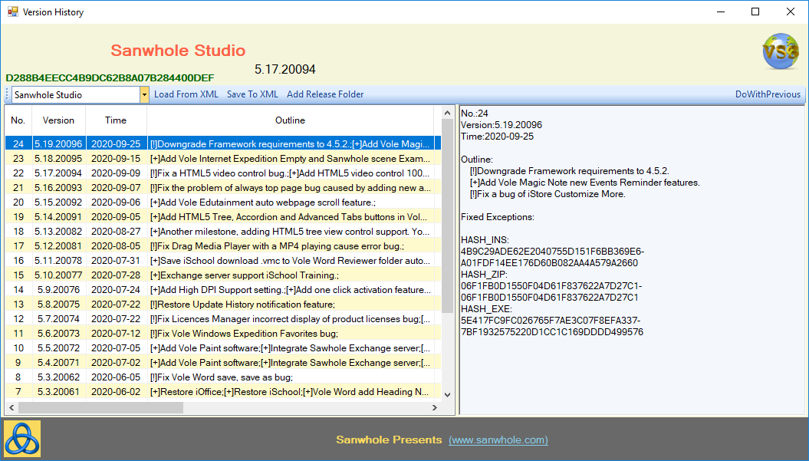

Software Name: Sanwhole Studio
Running Software Version: 5.17.20094
Running Current EXE Hash = D288B…0DEF

Click the left version history list, the detail will show in the right box, in the picture it shows the latest version:
Software Version: 5.19.20096
Release Time: 2020-09-25
Changing log includes Number, Version, Time, Outline etc.
- HASH_IN: installer version MD5 value.
- HASH_ZIP: portable version MD5 value.
- HASH_EXE: exe MD5 value.
You can calculate the installer MD5 value via MD5 tools before install if you get the installer not from Sanwhole.

Compatible Checker
You may use Compatible Checker to check current software compatible status. If can also check other Sanwhole software compatible results for your PC.
Tips: To use this feature, you need to run the program as an administrator.
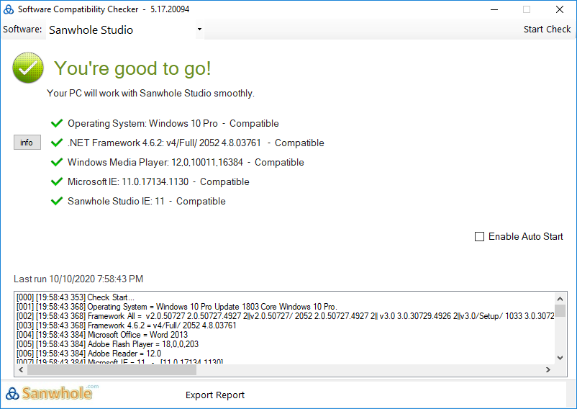

Preferred Software

How To
Go to Sanwhole website to find the help.

Countdown Timer
You can set the countdown time via the preset minute values or enter yours. The remaining time will be display in the top Quick Access Toolbar when the timer starts. When the time is up, the text box will display the exceed time and play sound until you stop the time.
Here’s how it works:
- Set the time you want.
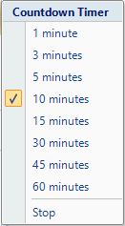
- You will find the countdown timer show on the Quick Access Toolbar.
When the countdown is up, it will display the exceed time and play a bell until you click it to stop the timer.
FYI: Anytime you want to clear the countdown timer, just double click the countdown timer that on the Quick Access Toolbar.

Global Palette
Sanwhole Studio has more than 10 beautiful featured color themes relax your eyes.
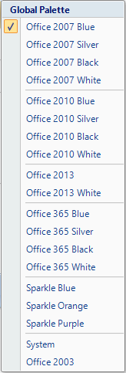

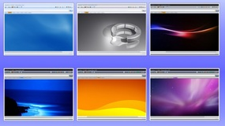

Supported Languages
Set the software languages as you want, and restart the software.
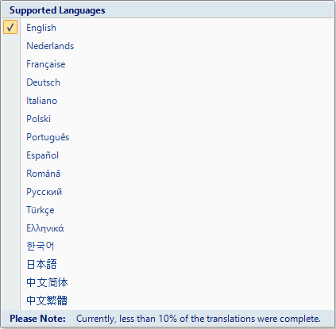

High DPI Support

Configure iMail Server Address
Set the iMail default Address as you want.

Set iOffice Server Address
Set the iOffice default Address as you want.

Set iSchool Server Address
Set the iSchool default Address as you want.

Activate this PC
Sanwhole Studio now support one click to active your PC.
You only need to enter your Sanwhole account and password and click Active button, then your software was active.

Redeem Purchase Code
If you have Sanwhole products redeem purchase code, you can use this function to redeem and active your software.

Specify Licenses File
If you have VoleLicenses.txt Licenses File, you may set the address to that file, and then the software is active.
Tips: Don’t change Licenses file name or content.

Manage Licenses
You can switch among edition, if you have more than one edition of software. You can enjoy different service duration and service level according to the corresponding edition.
There has 3 use scene for you: Business, person, school. You can easily to switch the use scene when you are in the different environment. When you close this window the setting will be saved automatically.

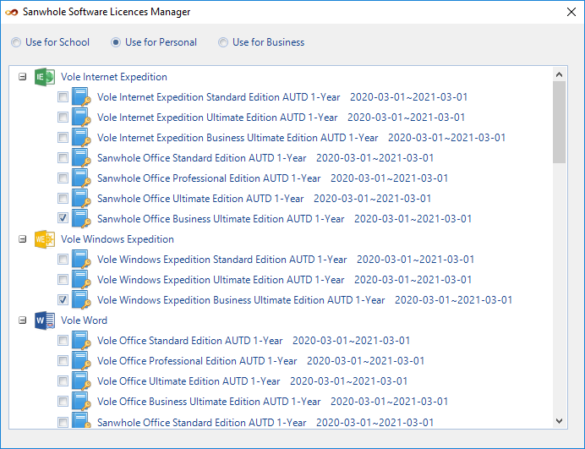

Quick Access Toolbar

Total Usage Time | Calculate the total time you work with the software.
Running Mode | Quickly and intuitively let you see what mode this software is running in.
Timer | Go Application -> Countdown Timer to learn more how to use this function.
User Name | Here will show your license user name.

Software Title
Structure: Current opening software name + Edition + Sanwhole Studio + (Version)
More Helps:
- How to active my computer?
Application -> Activate this PC
- How to manage my licenses?
Application -> Manage Licenses
- I have ‘VoleLicenses.txt’ file, what should I do next?
Application -> Specify Licenses File
- I have redeem/purchase code, what should I do next?
Application -> Redeem Purchase Code
- Where can I find the version history?
Application -> Version History

VWE Ribbon
Explorer | Single explorer.
Dual Explorer A B C | 3 dual explorer for you. Detail: Ribbon -> Dual Explorer.
My Desk | This is used for folder favorite. Detail: Ribbon -> My Desktop.
Scene Manager | You may find all scene at here. Detail: Ribbon -> Scene Manager.
Explorer Manager | Detail: Explorer Manager (Project manager).
Scene Page Shortcut | Detail: Scene Page Shortcut.
Create Explorer | Create explorer to the default folder. Vole Window Expedition has 7 category for you to category your explorer, they are: General, study, work, leisure, setting and VMC category. Detail: Ribbon -> My Desktop.
Save All | Save All Loaded Explorer When Quit.

Explorer
Each Vole Windows Expedition Explorer has documents previewer and file explorer. And it support Scene-Reproduce too.
- Documents Previewer
Any Vole Windows expedition explorer has documents previewer, it lets you view a variety of resources in the built-in media player.
You may preview images, audio, video, Microsoft Office Word, Excel, PDF, CHM, VMC, RTF, TXT, SWF, GIF, HTM, and HMT in the built-in media player. You can also preview online resources such as YouTube video, websites, webpage within VMC.
Category | The format of current preview.  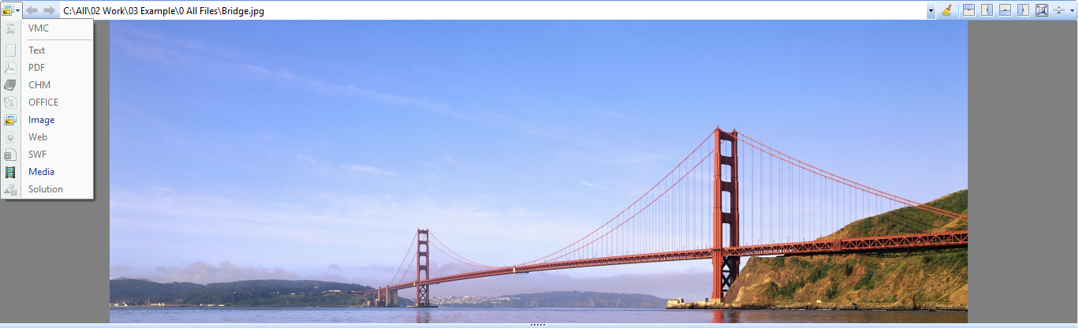
Move Previous | Preview previous file in history.
Move Next | Preview next file in history.
Media/Documents Address bar | Current preview file address.
Release the selected file | When you use the previewer previewing file, you can’t edit the file or move the file, etc. You can use this function to release the selected file let the previewer stop preview current file.
Move Top | Move document previewer window to top, explorer to bottom.
Move Right | Move document previewer window to right, explorer to left.
Move Bottom | Move document previewer window to bottom, explorer to top.
Move Left | Move document previewer window to left, explorer to right.
Esc Max Preview Mode | Let document previewer window to maximum size (Minimize the explorer).
View Rate | Document previewer window view rate.
Built-in multimedia Player | Built-in Control -> Built-in Multimedia Player.

- File Explorer
It is a full function fully compatible Windows file explorer.
Favorites | You may find all you saved favorites here. In order to facilitate users, the system commonly used shortcut directory can be found here too.
Save to Favorites | Add current folder to favorites.
Move Previous | Move to previous folder.
Move Next | Move to next folder.
Move Up | Mode Up to parent folder.
Address Bar | You can enter the address or select the folder as you want.
Search Textbox | Enter the text you want to search in current folder. How to: Enter the Search content (For example: *.png) and press Enter Key to start search.
Search Button | Click this button to switch between search view and explorer view.
Play and Pause | Play or pause all files in current folder.
Play Circle | Play in circle mode.
Add to current scene | Add the folder or selected file to current scene (My Desktop).  When the My Desktop Category is created, you can add file or folder to the category.  Here’s how it works:  Add File:  - Select the category you want to add file in My Desktop.  - Go to Explorer or Dual Explorer, selected file you want.  - Click Add to Current Scene Project button to add the file to the category.  - Click Save All button to save the changes.  Add Folder:  - Select the category you want to add folder in My Desktop.  - Go to Explorer or Dual Explorer, selected folder you want.  - Click Add to Current Scene Project button to add the file to the category.  - Click Save All button to save the changes.
Max Explorer | Full size of the explorer.
Pause Preview | Stop Documents Previewer to preview select file.

- What is Scene-Reproduce?
->Scene Manager
- What is Scene?
->Scene Manager
- What is My Desktop Category? And how to add category to My Desktop
->Category
- What is built-in Multimedia Player?
Built-in Control -> Built-in Multimedia Player.

Dual Explorer
Dual File Explorers
Four Dual full functional Vole Windows Expedition explorer.
Vole Windows Expedition dual explorer is a combination of two Windows file explorer. Each explorer is a full function fully compatible Windows file explorer. You can display the explorers in vertical or horizontal and you can prominent each explorer via one click.
And it support Scene-Reproduce too.
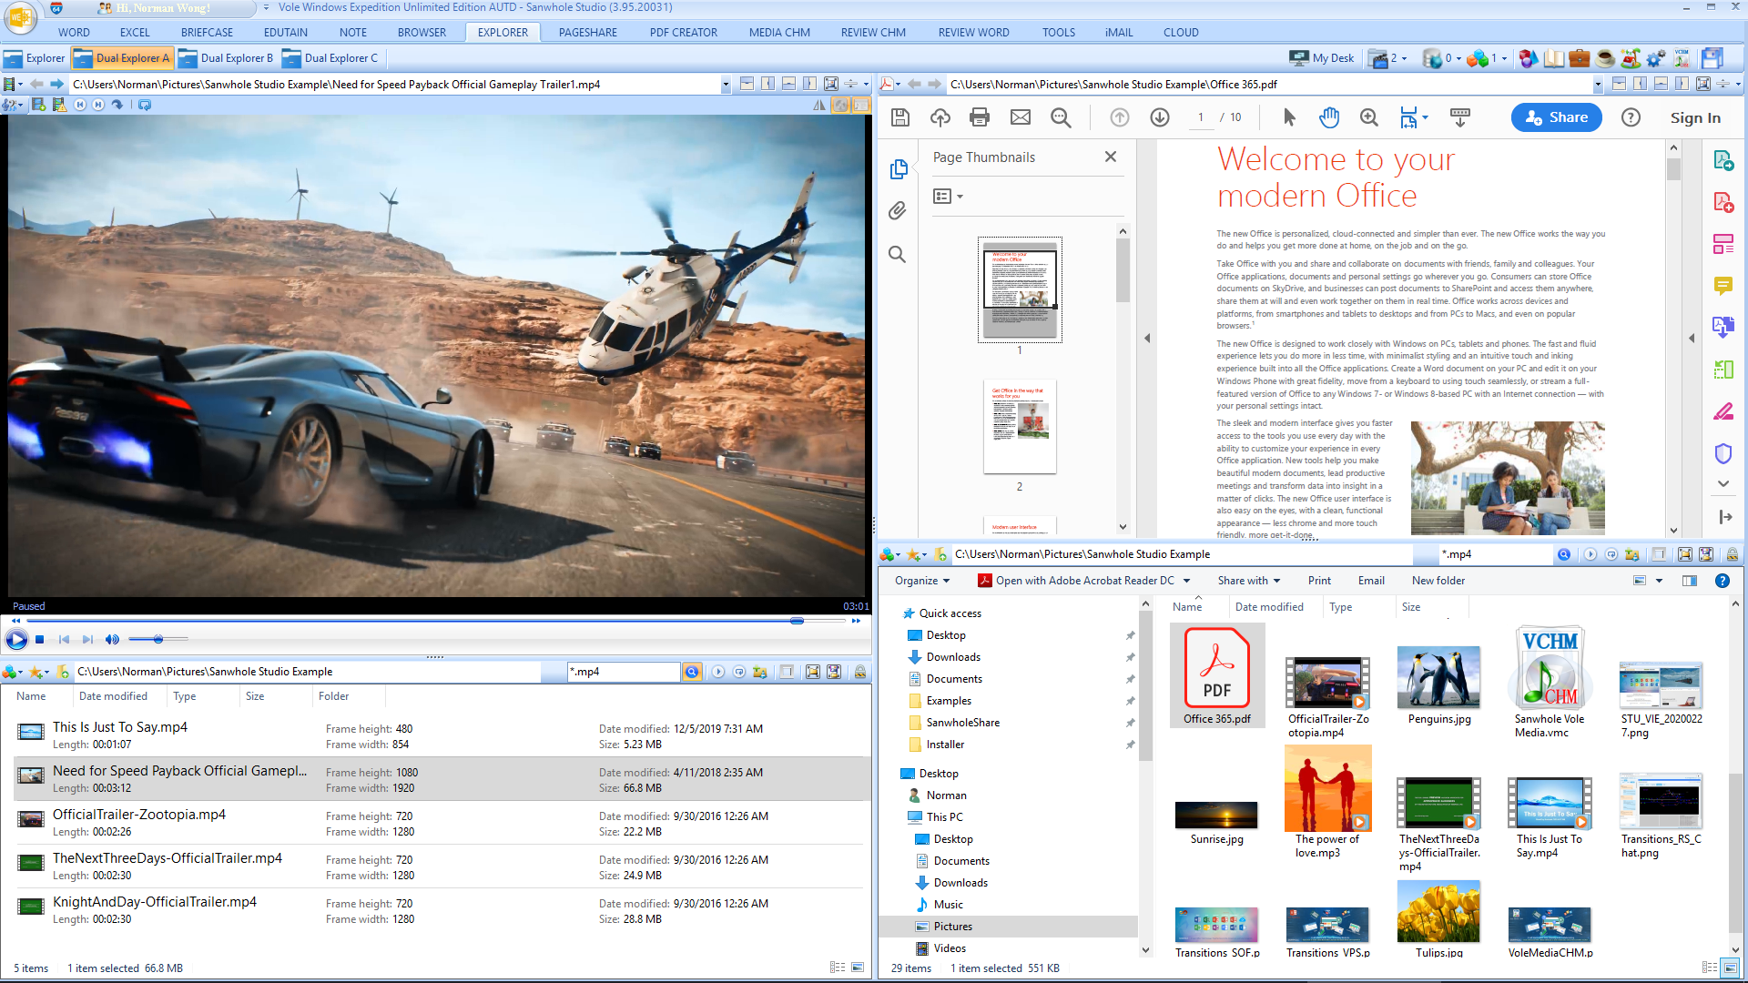

- What is Vole Windows Expedition explorer?
Go to Explorer.
- What is Scene-Reproduce?
Scene Manager

My Desktop
Five-level Topology
Files and folders, categories, projects, scenes and scene manager five-level topology structure, the heaviest loaded file manager.

Docking-Tabbed
Docking-Tabbed is premium window control technology that lets you dock and table window as you want, Parallel, Vertical, Horizontal, Float, Horizontal Group, Vertical Group, Prominent, etc. This lets you view your explorer more convenient than ever. Most of the software you can imagine cannot provide this complicated feature, such as Windows, Office, iTunes, etc. Up to now, any other file managers don't have this feature.

Scene Manager
Scene-Reproduce
One-click operate, gets all files and folder within any scene ready automatically. Instant navigation and accurate position. Scene-Reproduce feature will automatically save the opened files and folder and their docking configuration to your local disk and will restore the opened files and folder same as saved when starts. And more, scene can be exported and imported. If you export your scene and import to as many as other computers, BOOM, all the other computers will open files and folders same as yours.
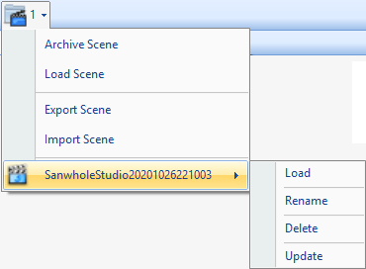
Archive Scene | Archive current scene to Scene Pool (In this picture, Scene Pool has one scene called SanwholeStudio202010261003).
Load Scene | Load scene by scene file (Vole Windows Expedition scene file extension is: .svwe).
Export Scene | Export current scene to the folder.
Import Scene | Import scene to Scene Pool by scene file.
Scene Pool | Load – Load the selected scene.  Rename – Rename the selected scene.  Delete –Delete the selected scene.  Update – Update current loaded scene to the selected scene.

Explorer Manager
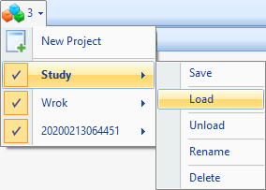
- New Projects
Create a new project in scene.
- Projects Pool
You may find all projects in the scene.
Save | Save current loaded explorer in My Desktop to current selected project.
Load | Load current selected project to My Desktop.
Unload | Unload current selected project.
Rename | Rename current project (In the picture, Study and Work project have been renamed, the project default name is time yyyyMMddHHmmss, and such as 20200213064451 is project default name).
Delete | Delete current selected project from scene.

Scene Page Shortcut
You may find all files in My Desktop at here, it can help you to find your file quickly.
Just click the file name, and the software will automatically jump to the file.
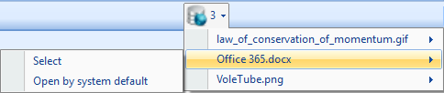

VWE Category
Create explorer to the default folder. Vole Window Expedition has 7 category for you to category your explorer, they are: General, study, work, leisure, setting and VMC category.
Of course, category support Scene-Reproduce (One-click operate, gets all files and folder within any scene ready automatically).
Learn More about Scene-Reproduce: Scene manager.

To get started:
- Click category button to add category to current project, then you will find the category in My Desktop.
In this picture, user added General, Study, Work, Live, Leisure and VMC category to current project.
- Click Save All button to save current loaded project to the scene.
FYI:
After you create a category, you can add files or folder to the category. Save the changes, and the next time you open the software, all files or folders and categories will be ready automatically.
- How to add files or folder to Category?
Explorer -> File Explorer -> Add to current scene project.

- Where is Save All button?
Ribbon -> Save All
- Where is Add to Current Scene Project button?
Explorer -> File Explorer -> Add to current scene project.

Built-in Multimedia Player
With built-in multimedia player, you may preview images, audio, video, Microsoft Office Word, Excel, PDF, CHM, VMC, RTF, TXT, SWF, GIF, HTM, and HMT in the built-in media player. You can also preview online resources such as YouTube video, websites, webpage within VMC.

- Preview Images:
Right click the image in previewer, you can choose the zoom rate you want (You can also use the mouse wheel to adjust zoom rate).
You can drag image the image to see the invisible part.
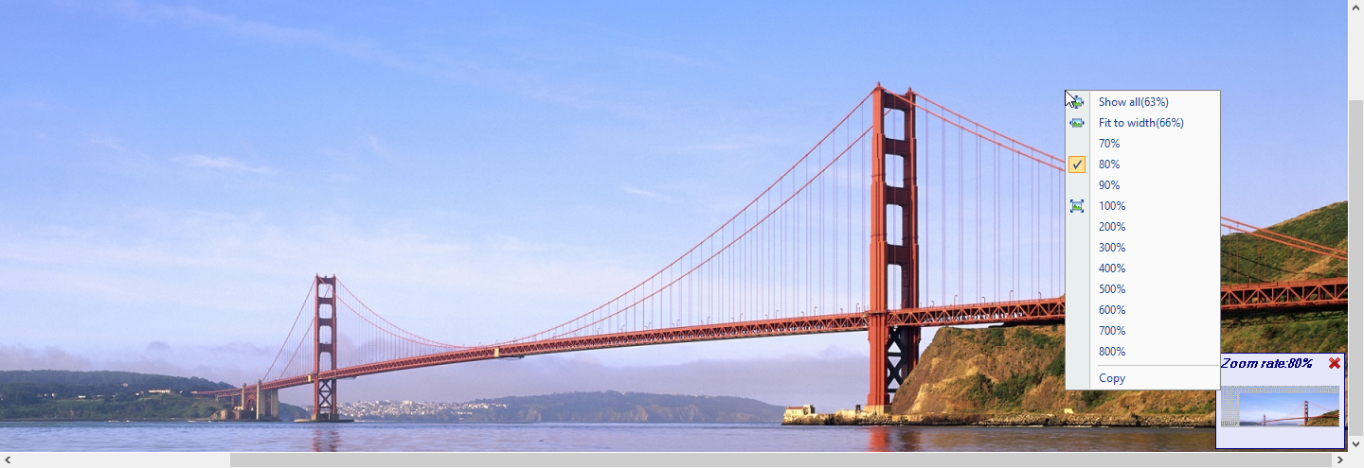
- Preview Audio or Video:
Play audio or video by built-in multimedia player.
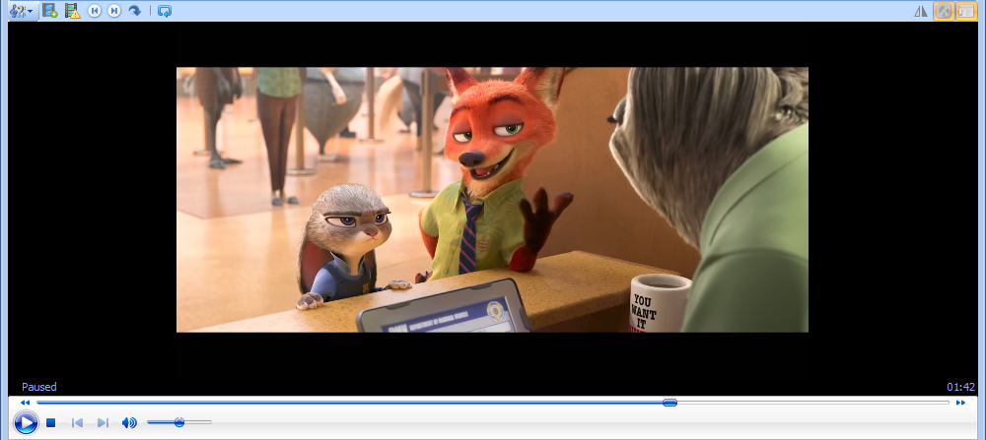
Music Mate | This feature is used for MP3 made by Sanwhole Tool Music Mate.
Connect | Connect media.
Release | Release media.
Circle Begin | Set play circle begin position.
Circle End | Set play circle end position.

Cancel Circle | Cancel the play circle (Clear circle begin and end position).
Play Circle | Turn on the circle play mode.

- Microsoft Office Word (.doc, .docx, etc.)
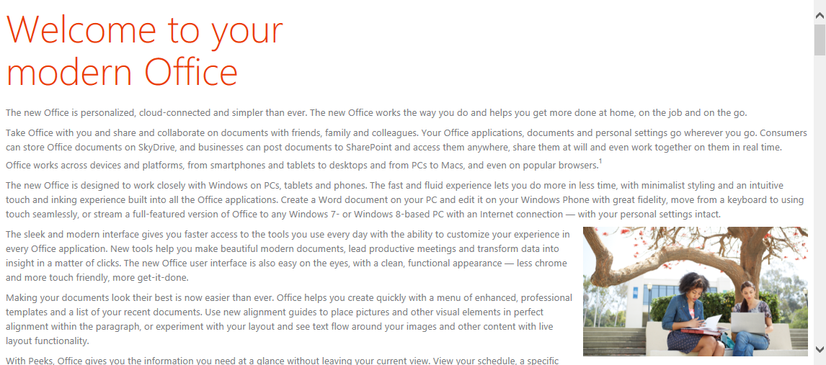
- Microsoft Office Excel (xlsx, etc.)
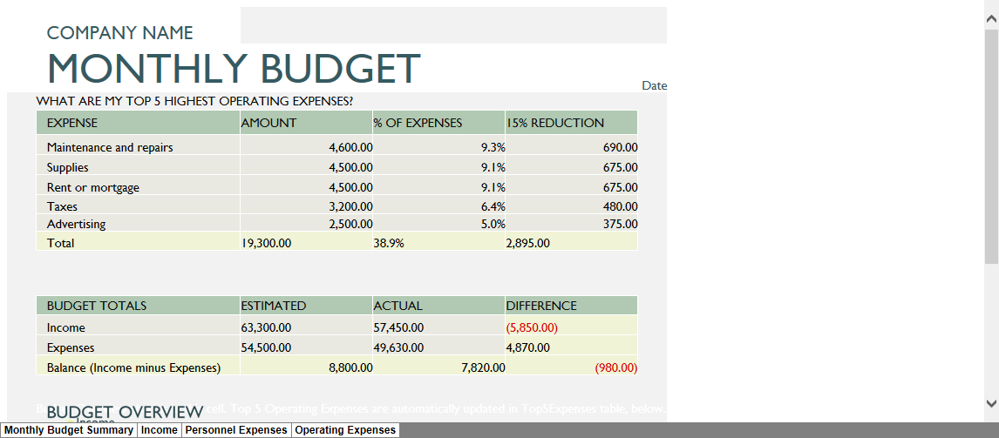
- Adobe PDF
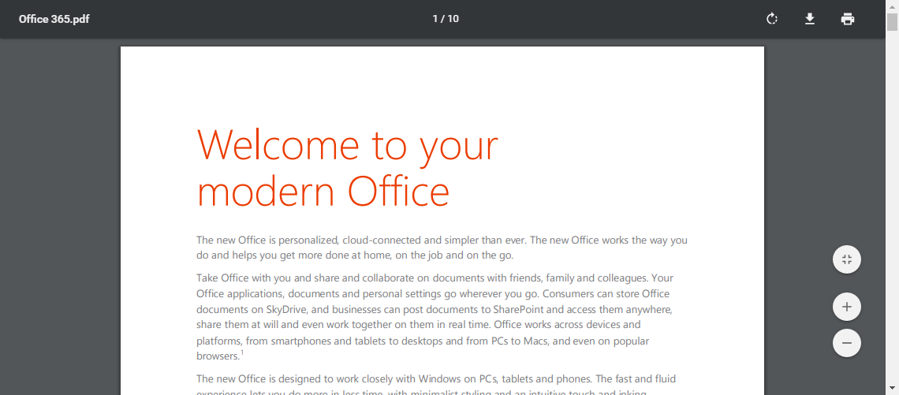

- HTM, HTML, HMT or online website, webpages
Use Vole Internet Expedition browser to preview HTM, HTML, MHTML, HMT or online website, webpages.
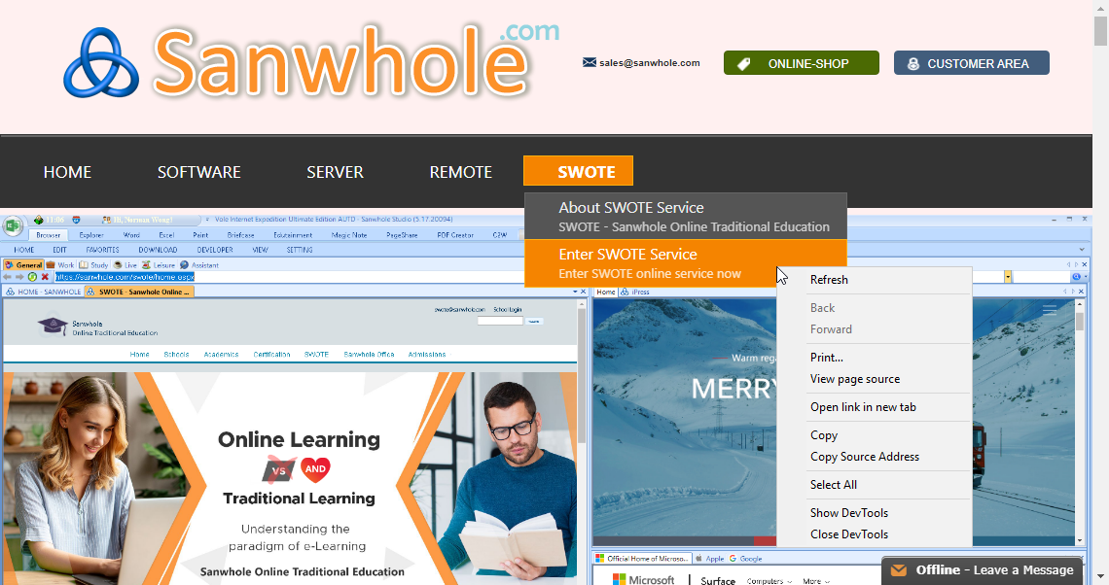
And it support DevTools, too.
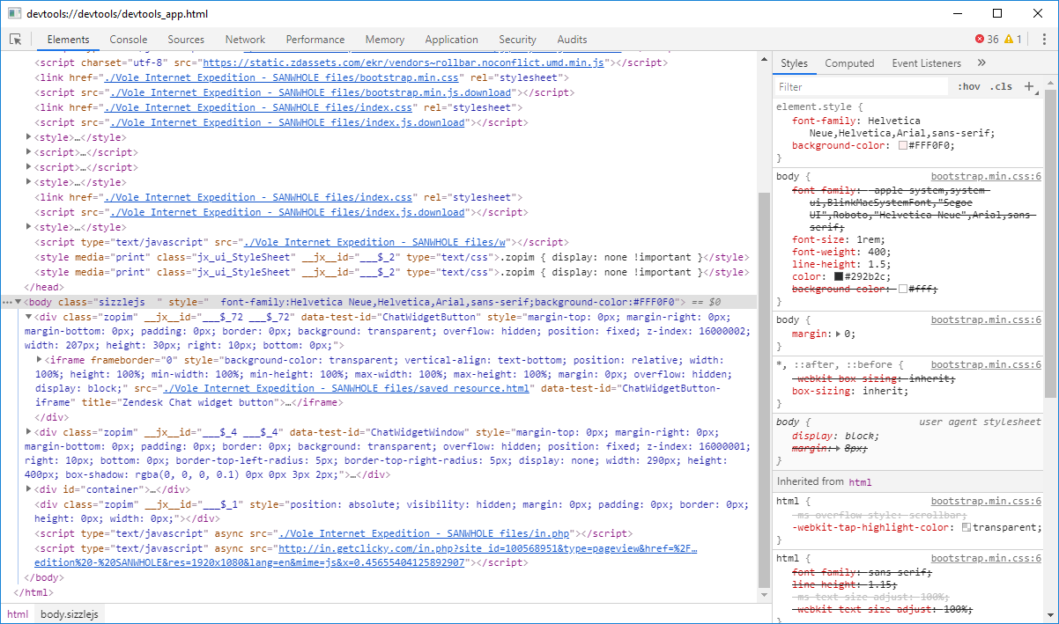

- VMC or CHM
Use VMC Reader to preview VMC or CHM.
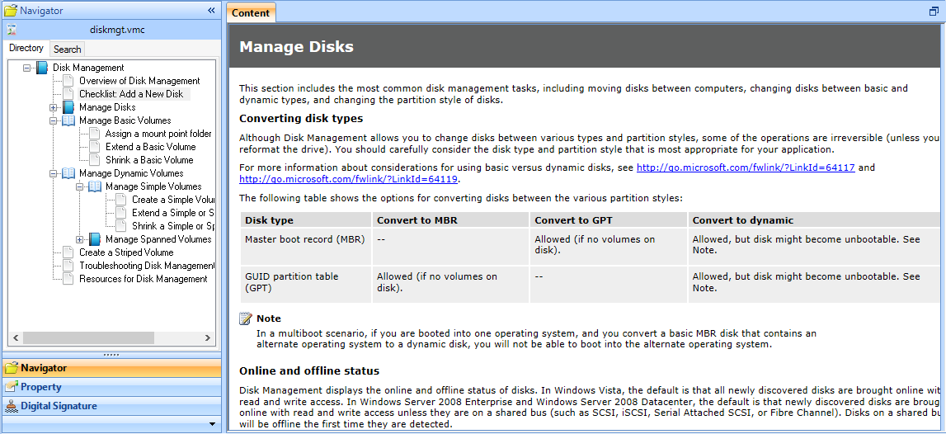

Advance (A)

MD5
The MD5 message-digest algorithm is a widely used cryptographic hash function producing a 128-bit (16-byte) hash value, typically expressed in text format as a 32 digit hexadecimal number. MD5 has been utilized in a wide variety of cryptographic applications, and is also commonly used to verify data integrity.
The software uses the MD5 algorithm verification document. No matter how the file name or attributes change, if the MD5 value same the file contents are same.

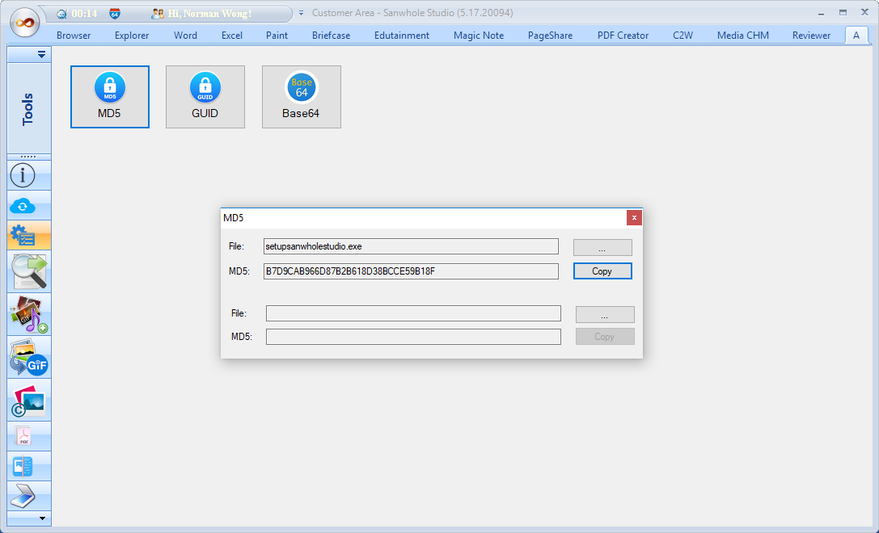

GUID
GUID creator. GUID - globally unique identifier is a unique reference number used as an identifier in computer software.
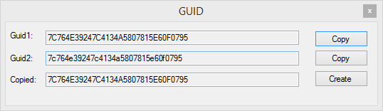

Base64
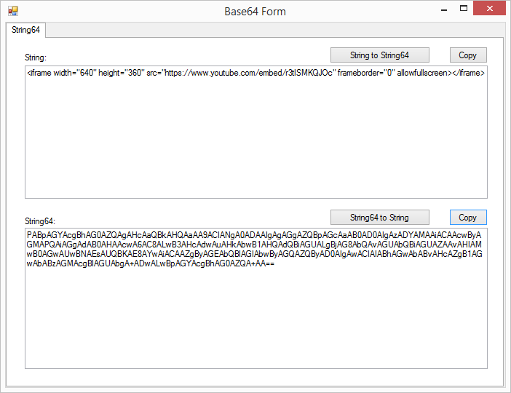

Find and Replace
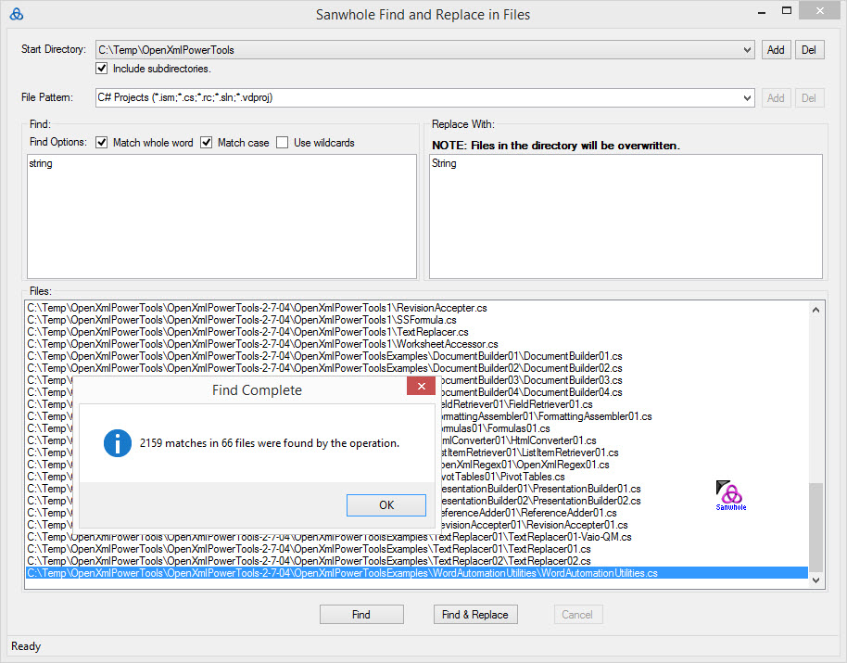

Music Mate
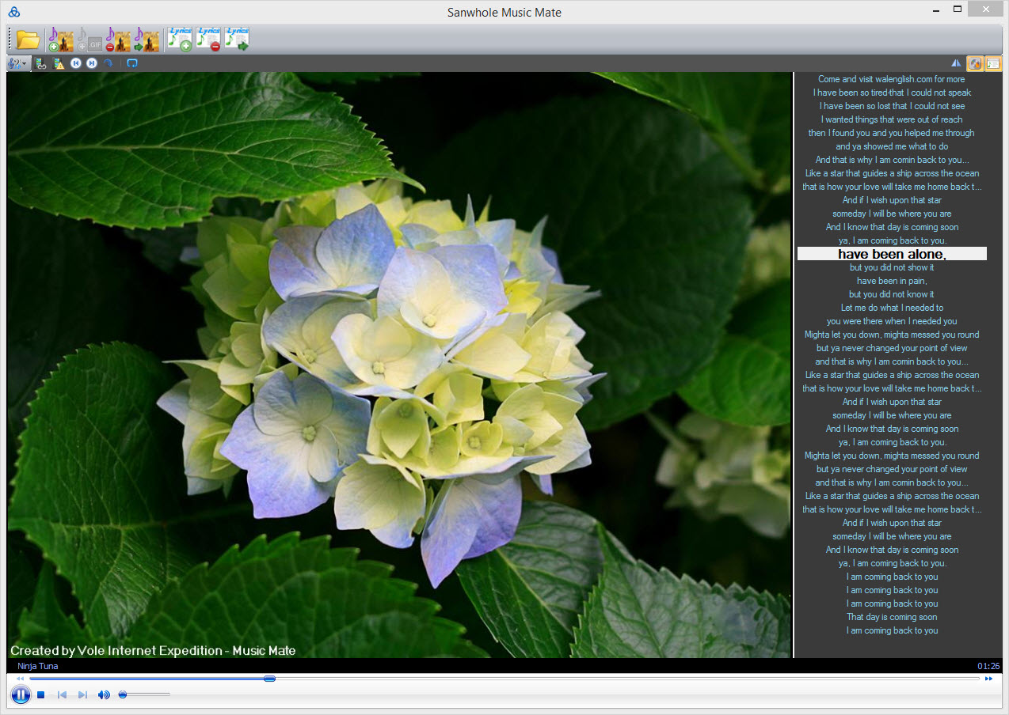

Music Mate Toolbar
Open Music | Open other music that you want to edit.
Add Image Art Cover to music | Add an image that you want to cover to current music.
Add GIF Art Cover to music | Add a GIF that you want to cover to current music.
Remove Art Cover from music | Remove art cover from current music.  Note: The current art cover will never comeback, if you don’t have current art cover.
Export Art Cover from music | Export art cover from current music.
Add Lyrics to music | 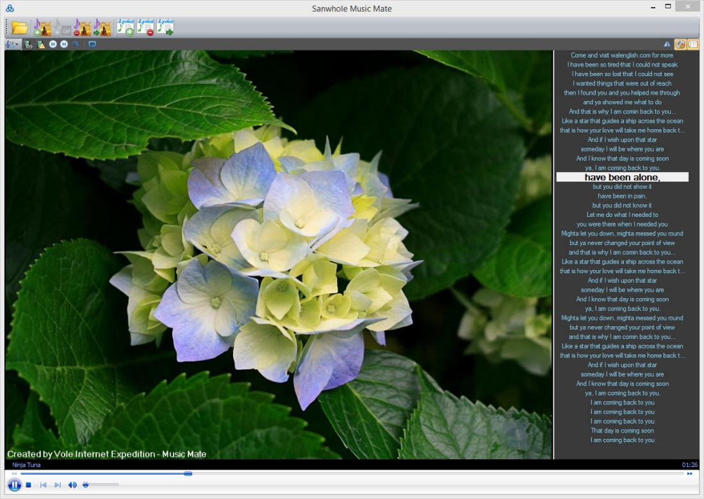  Lyrics
Remove Lyrics from music | Export Lyrics from music

Magic GIF
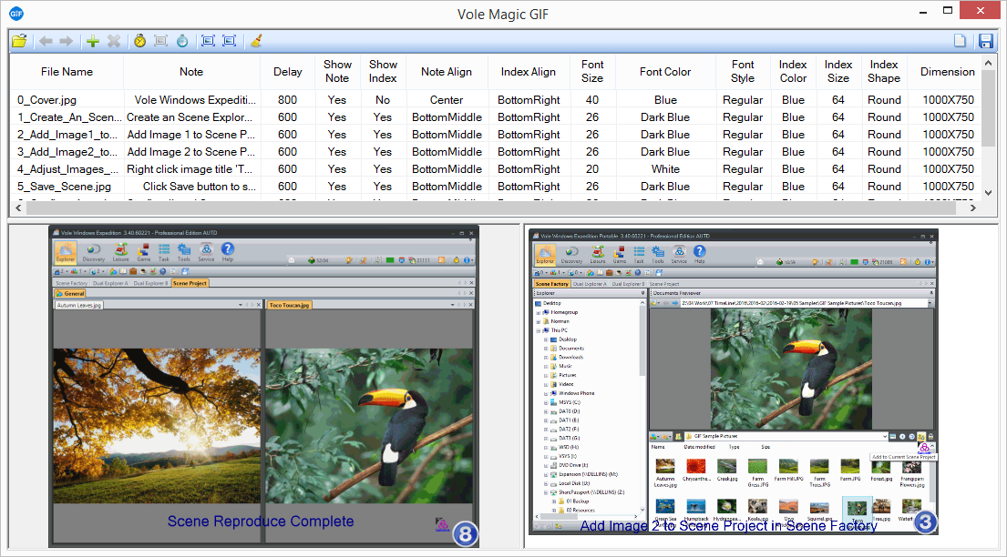

Magic GIF Toolbar
Load GIF | Open a GIF file that you want to edit from disk.
Move to prev. | Move selected picture to next.
Move to next | Move selected picture to next.
Add Image | Add image from disk
Remove Images | Remove selected image.
Set same delay to frames in percent seconds | Set same delay to frames in percent seconds.  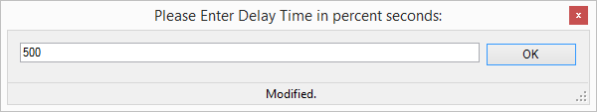
Set same size to frames
Add same delay rate to frames | 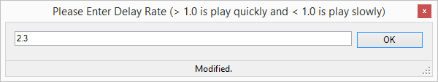
Add same size rate to frames
Zoom GIF to customized size
Format Brush | Use format brush to format the line you select.
Clear All | 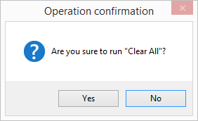
Clear all images for new GIF. | Clear all images in the list.
Ready | Save the gif, and show it.

Images Watermark
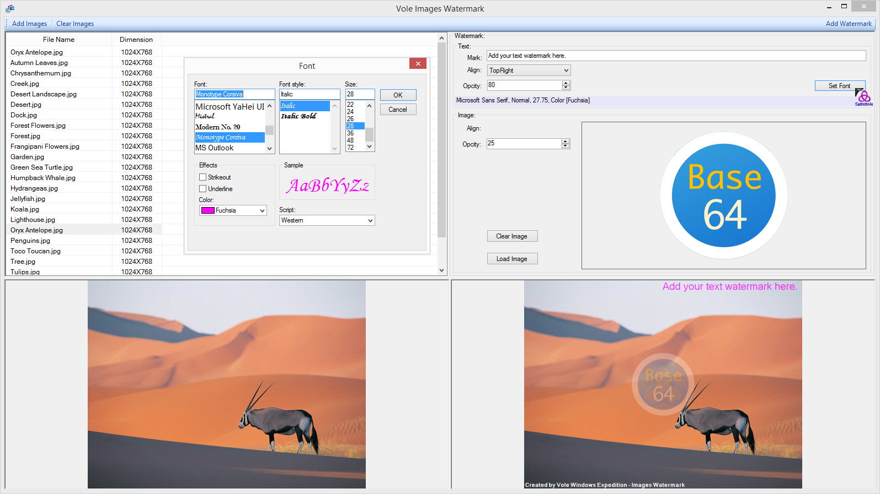
Add Images | Add image from your computer.
Clear Images | Clear all images in the list.

Here’s how it works:
- Click Add Image button to add the images to the list.
- Set the watermark to image at right panel.
- If the result is as you want, click Add Watermark button and all images in the list will added the watermark.

PDF Box
- Merge
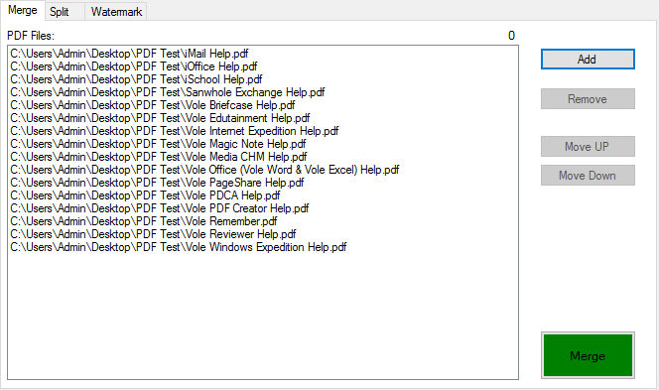
Add | Add the pdf to list.
Remove | Remove the selected pdf from list.
Move Up, Move Down | Change the order of the list.
Merge | Merge all pdf in the list.

- Split
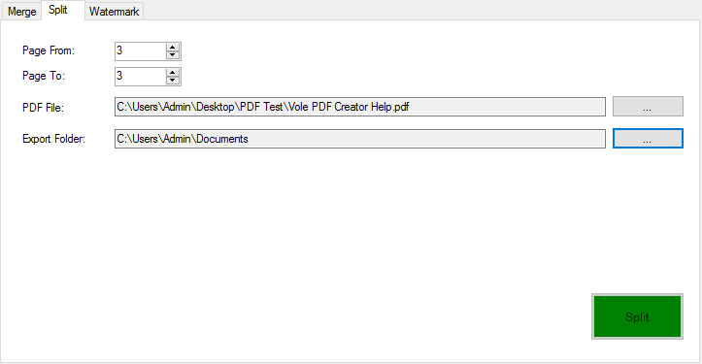
Page From | Split from.
Page To | Split to.
PDF File | Choose the pdf file you want to split.
Export Folder | Set the folder to export.

- Watermark
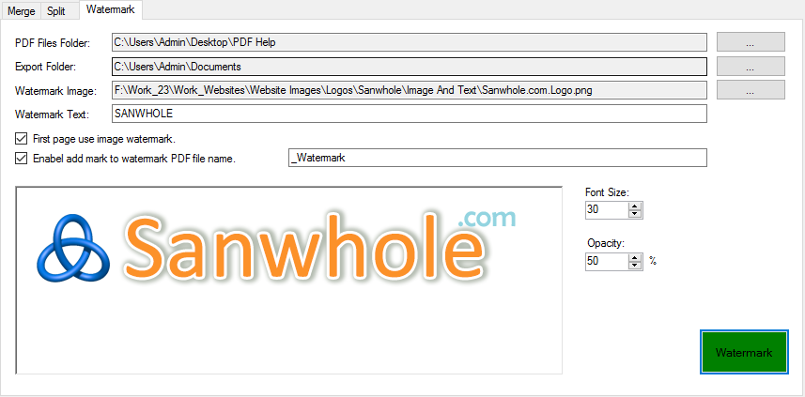
PDF Files Folder | Split from.
Export Folder | Split to.
Watermark Text | Choose the pdf file you want to split.
First page use image watermark | Set the folder to export.
Enable add mark to watermark PDF file name | All export pdf file name will add the string (In this picture, all pdf file name will add “_Watermark”).
Font Size | Watermark text font size.
Opacity | Set watermark text and image opacity.

OCR

Scanner

Vole Windows Expedition How To

Select Single, Dual, Tri and Quad File Explorer
By selecting file explorer page header Explorer, Dual Explorer A, Dual Explorer B, Dual Explorer C, Dual Explorer D, Tri Explorer and Quad Explorer, you can select the corresponding file explorer. File explorer is independent of each other. The selected file explorer will be displayed at the front. Other file browsers will automatically move to the back without being visible. When the file explorer is selected again, the display content will not change.

File Explorer Maximizing
In single file explorer, you can click Max Explorer button to maximize file explorer directory part. File explorer previewer part will be collapsed. In dual, tri and quad file explorer, you can click Max Explorer and Previewer button to maximize the whole explorer director part and previewer part. And then you can click the same button to restore original status.

File Preview and Pause Preview
You can preview the selected file when Pause Preview button is unchecked. If you don’t want to preview the selected file, you can check Pause Preview button like this . Pause Preview button check status will be automatically saved to ensure that your latest settings are still restored after software restart. The current previewed document will be automatically saved too. When the software restart, your last previewed document will be open automatically.

Clear Previewer
If you don’t want to the software automatically preview the current selected document. Or since the previewer occupy the selected file that cause others program cannot access it. You can click the Release the Selected File button .

Searching in File Explorer
To search in file explorer, you can type the search content such *.png in search textbox and then click Enter key or the next search button . To switch back to file explore, you can click search button again.

Type Current Path
Double click the current path bar to show textbox bar mode, like this . Double click again will retore the original status.

Play Folder
Click Folder Play button to automatically play audio, video media one by one in the current folder. Click Play Circle button to play folder media circularly. Manually click media file will jump to your select media from current play position.

Organize Favorite Folder
First select folder and then click Save to Favorite button to save your favorite folder. Favorite folders are shared among all the file explores. Vole Windows Expedition presets 7 favorite categories, they are General, Learn, Live, Leisure, Assistant and VMC.

Fast Access Favorite Folder
Click Favorite button to fast access your favorite folder.

File Explorer Scenes Reproduce
File Explorer Scenes Reproduce
File explorer settings include current preview document, current selected folder, file explorer directory and file previewer splitter position, file previewer orientation, Pause Preview button status, etc. will be save to database. When the software restart, file explorer will display itself same as the original position and size. And navigate to the same folder and open and preview the same file.
Learn how to prevent preview document at startup, see the topic Clear Previewer.

My Desktop Scenes Reproduce
Vole Windows Expedition lets you customize your virtual desktop – My Desktop include opened files and navigated folders. It can be a as simple as Windows file explorer or a very complicated desktop.
My Desktop can be restored to the original saved state after restarting. We call this Scenes Reproduce. This can help you use the file manager more elegantly and save you a lot of time.

Add file to My Desktop
Select an image, audio, video, PDF, DOCX or others document and click Add to Current Scene Project button to add your selected file to My Desktop.
You can see the previewed file in My Desktop.

Add folder to My Desktop
Select a folder at file explorer directory tree and click Add to Current Scene Project button to add your selected file to My Desktop.
You can see the previewed folder in My Desktop.

Save My Desktop
Click Save button to save the current scene. Then the saved scene will be restored every time restart.

Create Category in Desktop
My Desktop can have one or more categories. You can place unlimited files and folder into one category.
There are 7 preset scene categories. Click the relevant button to create relevant categories. You can place files and folders to different categories. Select the category that you want to save to and then do Add file to My Desktop can add file to your specified category.

Create Project in Desktop

My Desktop can have one or more projects. You can place unlimited categories into one project.
Click Explorer Manger button to create new project. You also run Load, Unload, Rename and Delete project feature within the button.

Archive Scene
You can click Scene Manager button to manage scene include archive, load, export and import scenes.
Archive Scene archives the current scene to a scene file and save into Scene Manager. Click Scene Manager button, you will find all saved scenes.

Load Scene
Select scene saved in Scene Manager , you can rapid load saved scene to current scene.

Export and Import Scene
You can export scene to a single file and import it into your laptop or working computer. This can help you use the file manager more elegantly and save you a lot of time.

