HOME
​Become one with the mountain

Highpeak Mountain tours are perfect for the outdoorsy type person looking to experience a once in a lifetime adventure. We curated our tours from a team of thrill seekers, adventurous and knowledgable people that love what nature has to offer. |  | We provide taylor made tours to satisfy your outdoors calling. From 14,000 feet mountain tops, to crystal clear river and lake kayaking, Highpeak has the adventure you’ve been longing for. Come with us on a journey and become one with the mountain. ​

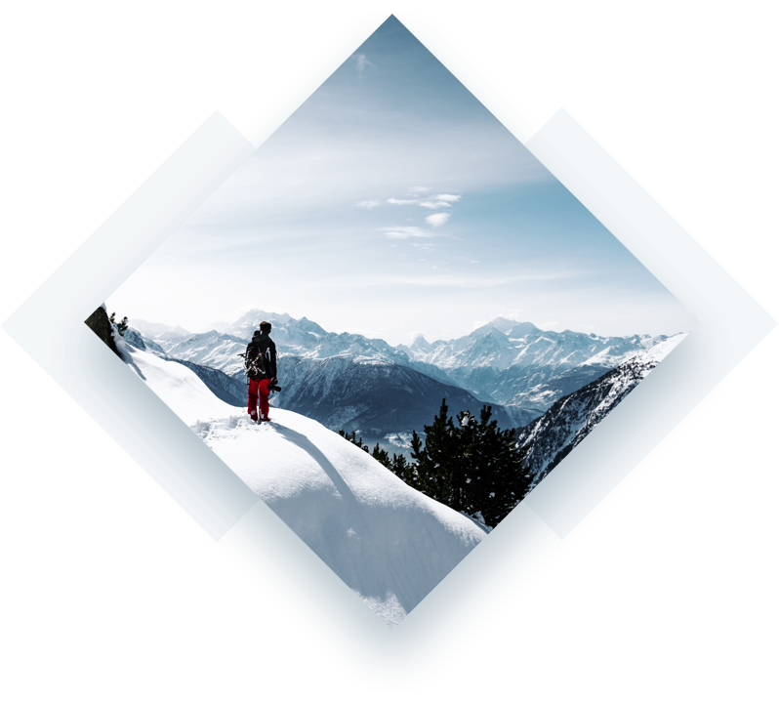

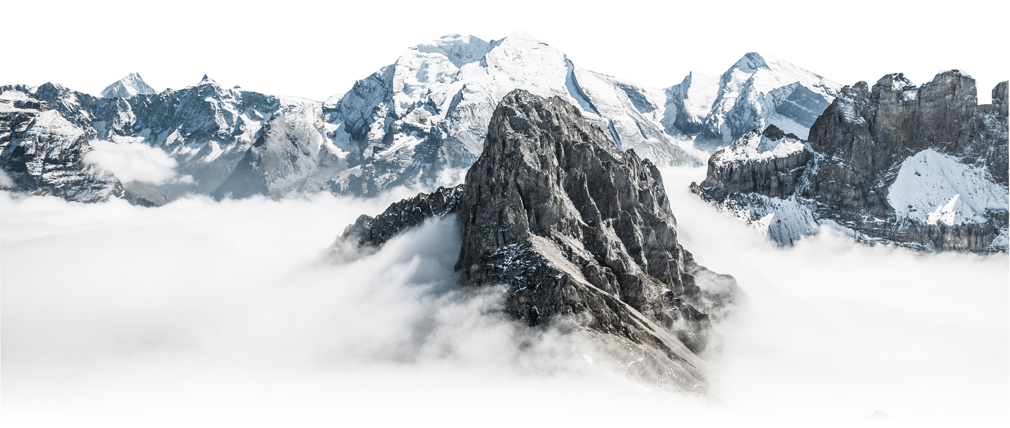

 | Breathtaking adventures
 | From over 500 different mountain adventures, Highpeak is the tour company to use. Not only are our guides effecitve in giving you the best journey, we’re knowledgable about the areas we venture out into. So no matter what you’re looking for, Highpeak has it. From 14,000 feet in the air, to multiple day long hikes and camping under the stars, we’ve got you covered. Come explore the nations most beautiful and scenic areas with us, we’re certain you’ll be wanting more. ​ | DEC JAN FEB  DAY HIKE HALF DAY DAY HIKE  OVERNIGHT OVERNIGHT 2-DAY  3-DAY 2-DAY 3-DAY

Nature calls. Will you answer?
To edit, simply click directly on the text and add your own words.
Use this text to go into more detail about who you are.

KAYAKING  ﻿Explore the clear waters of Hanging Lake or, Lake Tahoe. Kayak with Highpeak on adventures that will leave you speachless to say the least. Book a kayak tour today! | FREE CLIMBING  Does free climbing down a steep mountain get your juices flowing? Embark on a hike and climb adventure with our knowledgable climbing guides. | MOUNTAIN BIKE  From high in the Seirras to up in the clouds, mountain biking with Highpeak will prove to be a challenging adventure you won’t soon forget.
VIEW TOURS | VIEW TOURS | VIEW TOURS

Proudly powered by Sanwhole

SERVICES

Services
Edit this text to make it your own. To edit, simply click directly on the text and start typing. Break up your text with more than one paragraph for better readability. You can decorate your text with all kinds of Office Word text styles as well. Don’t use heading properties in text, and only use heading properties to menu.

KAYAKING  Explore the clear waters of Hanging Lake or, Lake Tahoe. Kayak with Highpeak on adventures that will leave you speachless to say the least. Book a kayak tour today! | FREE CLIMBING  Does free climbing down a steep mountain get your juices flowing? Embark on a hike and climb adventure with our knowledgable climbing guides. | MOUNTAIN BIKE  From high in the Seirras to up in the clouds, mountain biking with Highpeak will prove to be a challenging adventure you won’t soon forget.

DEC | JAN | FEB
DAY HIKE | HALF DAY | DAY HIKE
OVERNIGHT | OVERNIGHT | 2-DAY
3-DAY | 2-DAY | 3-DAY

Proudly powered by Sanwhole

ABOUT
We are Highpeak
Edit this text to make it your own. To edit, simply click directly on the text and start typing. Break up your text with more than one paragraph for better readability. You can decorate your text with all kinds of Office Word text styles as well. Don’t use heading properties in text, and only use heading properties to menu.

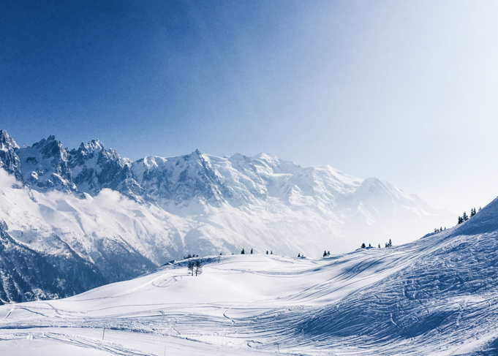 | 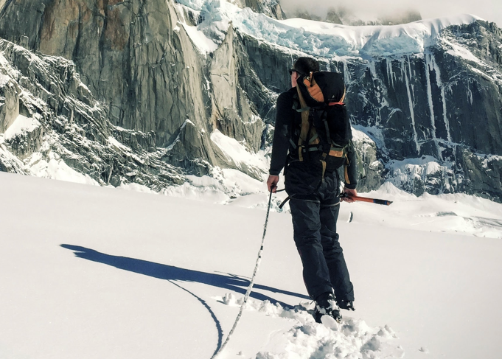

Edit this text to make it your own. To edit, simply click directly on the text and start typing. Break up your text with more than one paragraph for better readability. You can decorate your text with all kinds of Office Word text styles as well. Don’t use heading properties in text, and only use heading properties to menu.

Proudly powered by Sanwhole

CONTACT
Contact Us
Edit this text to make it your own. To edit, simply click directly on the text and start typing. Break up your text with more than one paragraph for better readability. You can decorate your text with all kinds of Office Word text styles as well. Don’t use heading properties in text, and only use heading properties to menu.

Proudly powered by Sanwhole

Download

Download more templates
Click here to download more templates

Proudly powered by Sanwhole

