HOME
Space Science News Center Home
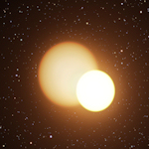 | Metallic Glass Yields Secrets Under Pressure  Mar. 16, 2010  Metallic glasses are emerging as potentially useful materials at the frontier of materials science research. They combine the advantages and avoid many of the problems of normal metals and glasses, two classes of materials with a very wide range of applications. For example, metallic glasses are less brittle than ordinary glasses and more resilient than conventional metals. Metallic glasses also have unique electronic behavior that scientists are just beginning to understand. | Sanwhole  RSS FEEDS  SANWHOLE  Space Science  Sanwhole
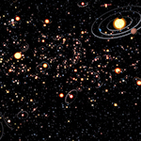 | Planet Population is Plentiful  Jan. 11, 2012  An international team of astronomers has searched for exoplanets using a totally different method -- gravitational microlensing -- that can detect planets over a wide range of mass and those that lie much further from their stars.
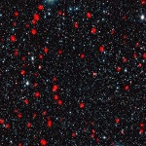 | Distant star-forming galaxies in the early Universe  Jan. 25, 2012  Astronomers have combined observations from the LABOCA camera on the ESO-operated 12-meter Atacama Pathfinder Experiment (APEX) telescope with measurements made with ESO’s Very Large Telescope, NASA’s Spitzer Space Telescope, and others, to look at the way that bright, distant galaxies are gathered together in groups or clusters.

© 2017 - SANWHOLE, All rights reserved.
Proudly powered by Sanwhole

SPACE

Tuesday, March 16, 2010
Pulsating Star Mystery Solved  Wednesday, November 24, 2010  Credit: ESO/L. Calçada By discovering the first double star where a pulsating Cepheid variable and another star pass in front of one another, an international team of astronomers has solved a decades-old mystery. The rare alignment of the orbits of the two stars in the double star system has allowed a measurement of the Cepheid mass with unprecedented accuracy. Up to now astronomers had two incompatible theoretical predictions of Cepheid masses. The new result shows that the prediction from stellar pulsation theory is spot on, while the prediction from stellar evolution theory is at odds with the new observations. The new results, from a team led by Grzegorz Pietrzyński (Universidad de Concepción, Chile, Obserwatorium Astronomiczne Uniwersytetu Warszawskiego, Poland), appear in the 25 November 2010 edition of the journal Nature. Grzegorz Pietrzyński introduces this remarkable result: “By using the HARPS instrument on the 3.6-meter telescope at ESO’s La Silla Observatory in Chile, along with other telescopes, we have measured the mass of a Cepheid with an accuracy far greater than any earlier estimates. This new result allows us to immediately see which of the two competing theories predicting the masses of Cepheids is correct.” Classical Cepheid Variables, usually called just Cepheids, are unstable stars that are larger and much brighter than the Sun. They expand and contract in a regular way, taking anything from a few days to months to complete the cycle. The time taken to brighten and grow fainter again is longer for stars that are more luminous and shorter for the dimmer ones. This remarkably precise relationship makes the study of Cepheids one of the most effective ways to measure the distances to nearby galaxies and from there to map out the scale of the whole Universe. Unfortunately, despite their importance, Cepheids are not fully understood. Predictions of their masses derived from the theory of pulsating stars are 20–30% less than predictions from the theory of the evolution of stars. This embarrassing discrepancy has been known since the 1960s. 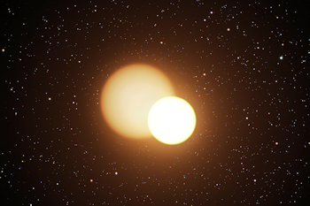 This artist’s impression shows the double star OGLE-LMC-CEP0227 in our neighboring galaxy the Large Magellanic Cloud. The smaller of the two stars is a pulsating Cepheid variable and the orientation of the system is such that the stars eclipse each other during their orbits. Studies of this very rare system have allowed astronomers to measure the Cepheid mass with unprecedented accuracy.  To resolve this mystery, astronomers needed to find a double star containing a Cepheid where the orbit happened to be seen edge-on from Earth. In these cases, known as eclipsing binaries, the brightness of the two stars dims as one component passes in front of the other, and again when it passes behind the other star. In such pairs astronomers can determine the masses of the stars to high accuracy. Unfortunately neither Cepheids nor eclipsing binaries are common, so the chance of finding such an unusual pair seemed very low. None are known in the Milky Way.  Wolfgang Gieren, another member of the team, takes up the story: “Very recently we actually found the double star system we had hoped for among the stars of the Large Magellanic Cloud. It contains a Cepheid variable star pulsating every 3.8 days. The other star is slightly bigger and cooler, and the two stars orbit each other in 310 days. The true binary nature of the object was immediately confirmed when we observed it with the HARPS spectrograph on La Silla.”  The observers carefully measured the brightness variations of this rare object, known as OGLE-LMC-CEP0227, as the two stars orbited and passed in front of one another. They also used HARPS and other spectrographs to measure the motions of the stars towards and away from the Earth — both the orbital motion of both stars and the in-and-out motion of the surface of the Cepheid as it swelled and contracted.  This very complete and detailed data allowed the observers to determine the orbital motion, sizes and masses of the two stars with very high accuracy — far surpassing what had been done before for a Cepheid. The mass of the Cepheid is now known to about 1% and agrees exactly with predictions from the theory of stellar pulsation. However, the larger mass predicted by stellar evolution theory was shown to be significantly in error.  The much-improved mass estimate is only one outcome of this work, and the team hopes to find other examples of these remarkably useful pairs of stars to exploit the method further. They also believe that from such binary systems they will eventually be able to pin down the distance to the Large Magellanic Cloud to 1%, which would mean an extremely important improvement of the cosmic distance scale.  Source: ESO | Sanwhole  RSS FEEDS  SANWHOLE  Space Science  Sanwhole

© 2017 - SANWHOLE, All rights reserved.
Proudly powered by Sanwhole

Wednesday, January 11, 2012
Planet Population is Plentiful  Wednesday, January 11, 2012  Over the past 16 years, astronomers have detected more than 700 confirmed exoplanets and have started to probe the spectra and atmospheres of these worlds. While studying the properties of individual exoplanets is undeniably valuable, a much more basic question remains: how commonplace are planets in the Milky Way? Most currently known exoplanets were found either by detecting the effect of the gravitational pull of the planet on its host star or by catching the planet as it passes in front of its star and slightly dims it. Both of these techniques are much more sensitive to planets that are either massive or close to their stars, or both, and many planets will be missed. An international team of astronomers has searched for exoplanets using a totally different method — gravitational microlensing — that can detect planets over a wide range of mass and those that lie much further from their stars. Arnaud Cassan (Institut dʼAstrophysique de Paris), lead author of the Nature paper, explains: "We have searched for evidence for exoplanets in six years of microlensing observations. Remarkably, these data show that planets are more common than stars in our galaxy. We also found that lighter planets, such as super-Earths or cool Neptunes, must be more common than heavier ones." 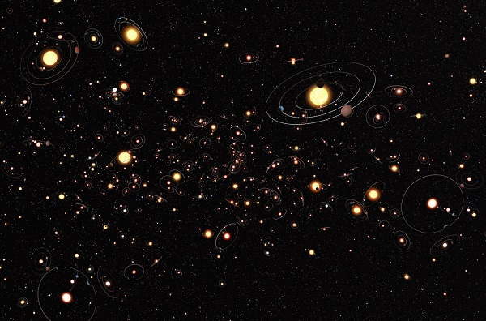 The LABOCA camera on the ESO-operated 12-meter Atacama Pathfinder Experiment (APEX) telescope reveals distant galaxies undergoing the most intense type of star formation activity known, called a starburst. ESO, APEX (MPIfR/ESO/OSO), A. Weiss et al., NASA Spitzer Science Center  The astronomers used observations, supplied by the PLANET and OGLE teams, in which exoplanets are detected by the way that the gravitational field of their host stars, combined with that of possible planets, acts like a lens, magnifying the light of a background star. If the star that acts as a lens has a planet in orbit around it, the planet can make a detectable contribution to the brightening effect on the background star.  Jean-Philippe Beaulieu (Institut d'Astrophysique de Paris), leader of the PLANET collaboration adds: "The PLANET collaboration was established to follow up promising microlensing events with a round-the-world network of telescopes located in the southern hemisphere, from Australia and South Africa to Chile. ESO telescopes contributed greatly to these surveys.”  Microlensing is a very powerful tool, with the potential to detect exoplanets that could never be found any other way. But a very rare chance alignment of a background and lensing star is required for a microlensing event to be seen at all. And, to spot a planet during an event, an additional chance alignment of the planet’s orbit is also needed.  Although for these reasons finding a planet by microlensing is far from an easy task, in the six year's worth of microlensing data used in the analysis, three exoplanets were actually detected in the PLANET and OGLE searches: a super-Earth, and planets with masses comparable to Neptune and Jupiter. By microlensing standards, this is an impressive haul. In detecting three planets, either the astronomers were incredibly lucky and had hit the jackpot despite huge odds against them, or planets are so abundant in the Milky Way that it was almost inevitable.  The astronomers then combined information about the three positive exoplanet detections with seven additional detections from earlier work, as well as the huge numbers of non-detections in the six year's worth of data — non-detections are just as important for the statistical analysis and are much more numerous. The conclusion was that one in six of the stars studied hosts a planet of similar mass to Jupiter, half have Neptune-mass planets and two thirds have super-Earths. The survey was sensitive to planets between 75 million kilometers and 1.5 billion kilometers from their stars (in the Solar System this range would include all the planets from Venus to Saturn) and with masses ranging from five times the Earth up to ten times Jupiter.  Combining the results suggests strongly that the average number of planets around a star is greater than one. They are the rule rather than the exception.  “We used to think that the Earth might be unique in our galaxy. But now it seems that there are literally billions of planets with masses similar to Earth orbiting stars in the Milky Way,” concludes Daniel Kubas, co-lead author of the paper.  Source: ESO | Sanwhole  RSS FEEDS  SANWHOLE  Space Science  Sanwhole

© 2017 - SANWHOLE, All rights reserved.
Proudly powered by Sanwhole

Wednesday, January 25, 2012
Distant star-forming galaxies in the early Universe  Wednesday, January 25, 2012  Astronomers have combined observations from the LABOCA camera on the ESO-operated 12-meter Atacama Pathfinder Experiment (APEX) telescope with measurements made with ESO’s Very Large Telescope, NASA’s Spitzer Space Telescope, and others, to look at the way that bright, distant galaxies are gathered together in groups or clusters. The more closely the galaxies are clustered, the more massive are their halos of dark matter — the invisible material that makes up the vast majority of a galaxy’s mass. The new results are the most accurate clustering measurements ever made for this type of galaxy. The galaxies are so distant that their light has taken around ten billion years to reach us, so we see them as they were about ten billion years ago. In these snapshots from the early Universe, the galaxies are undergoing the most intense type of star formation activity known, called a starburst. By measuring the masses of the dark matter halos around the galaxies, and using computer simulations to study how these halos grow over time, the astronomers found that these distant starburst galaxies from the early cosmos eventually become giant elliptical galaxies — the most massive galaxies in today’s Universe. “This is the first time that we've been able to show this clear link between the most energetic starbursting galaxies in the early Universe, and the most massive galaxies in the present day," explains Ryan Hickox (Dartmouth College, USA and Durham University, UK), the lead scientist of the team. 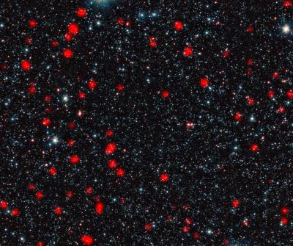 The LABOCA camera on the ESO-operated 12-meter Atacama Pathfinder Experiment (APEX) telescope reveals distant galaxies undergoing the most intense type of star formation activity known, called a starburst. ESO, APEX (MPIfR/ESO/OSO), A. Weiss et al., NASA Spitzer Science Center  Furthermore, the new observations indicate that the bright starbursts in these distant galaxies last for a mere 100 million years — a very short time in cosmological terms — yet in this brief time they are able to double the quantity of stars in the galaxies. The sudden end to this rapid growth is another episode in the history of galaxies that astronomers do not yet fully understand.  “We know that massive elliptical galaxies stopped producing stars rather suddenly a long time ago, and are now passive. And scientists are wondering what could possibly be powerful enough to shut down an entire galaxy’s starburst,” says Julie Wardlow (University of California at Irvine, USA and Durham University, UK), a member of the team.  The team’s results provide a possible explanation: at that stage in the history of the cosmos, the starburst galaxies are clustered in a very similar way to quasars, indicating that they are found in the same dark matter halos. Quasars are among the most energetic objects in the Universe — galactic beacons that emit intense radiation, powered by a supermassive black hole at their center.  There is mounting evidence to suggest the intense starburst also powers the quasar by feeding enormous quantities of material into the black hole. The quasar in turn emits powerful bursts of energy that are believed to blow away the galaxy’s remaining gas — the raw material for new stars — and this effectively shuts down the star formation phase.  “In short, the galaxies’ glory days of intense star formation also doom them by feeding the giant black hole at their center, which then rapidly blows away or destroys the star-forming clouds,” explains David Alexander (Durham University, UK), a member of the team.  Source: ESO | Sanwhole  RSS FEEDS  SANWHOLE  Space Science  Sanwhole

© 2017 - SANWHOLE, All rights reserved.
Proudly powered by Sanwhole

ABOUT
About Us

Edit this text to make it your own. To edit, simply click directly on the text and start typing. Break up your text with more than one paragraph for better readability. You can decorate your text with all kinds of Office Word text styles as well. Don’t use heading properties in text, and only use heading properties to menu.

© 2017 - SANWHOLE, All rights reserved.
Proudly powered by Sanwhole

CONTACT
Contact Us

Edit this text to make it your own. To edit, simply click directly on the text and start typing. Break up your text with more than one paragraph for better readability. You can decorate your text with all kinds of Office Word text styles as well. Don’t use heading properties in text, and only use heading properties to menu.

© 2017 - SANWHOLE, All rights reserved.
Proudly powered by Sanwhole

Download
Download more templates

Click here to download more templates

© 2017 - SANWHOLE, All rights reserved.
Proudly powered by Sanwhole

